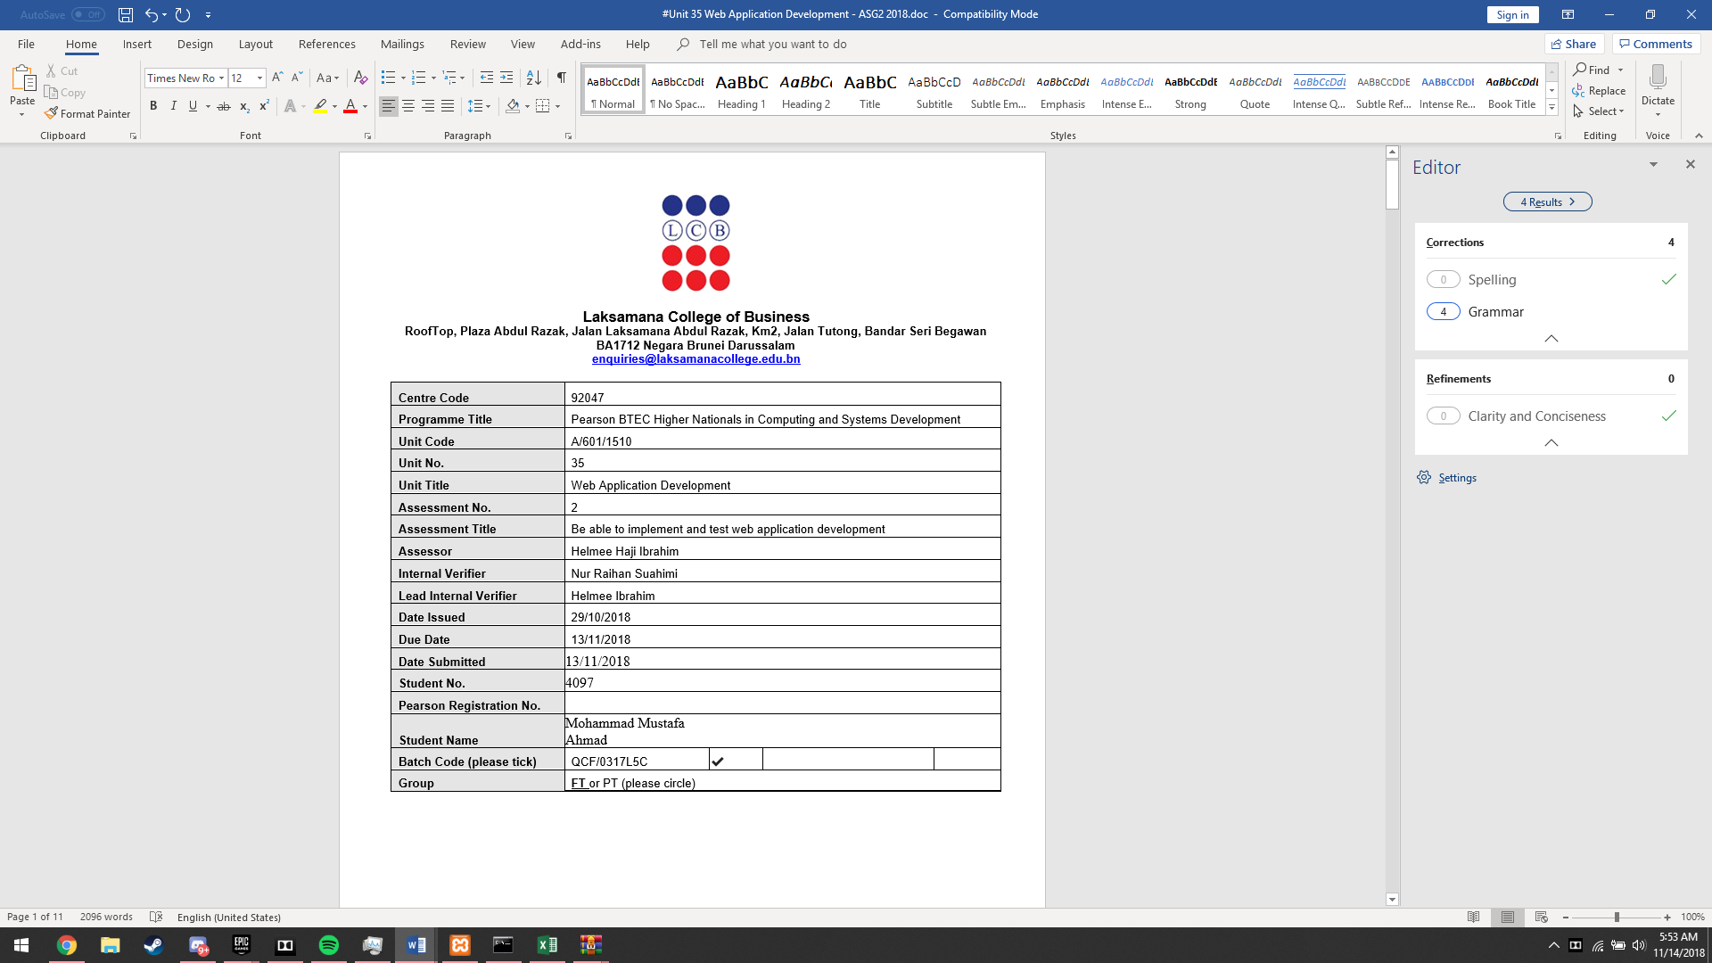

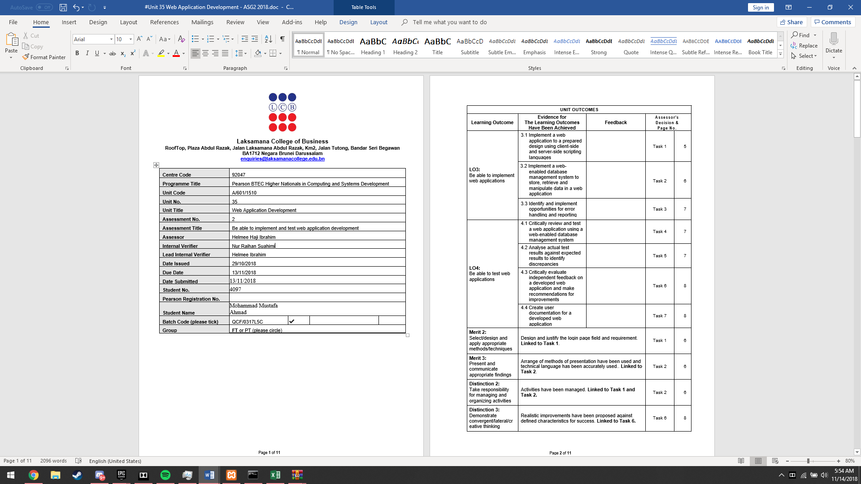
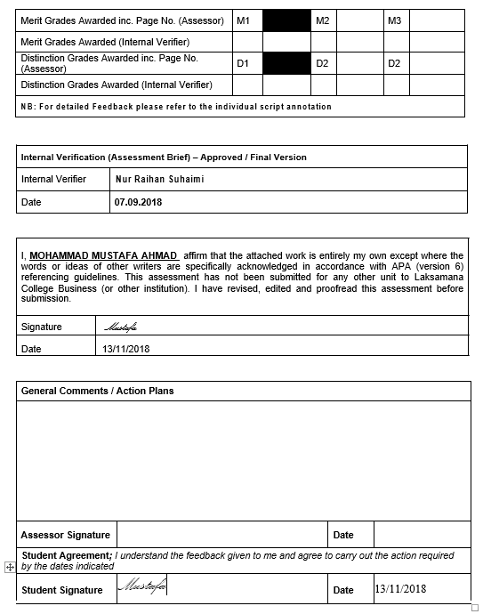

Table of Contents
List of Figures 4
Task 1 – Implementation of web application 7
Task 1.1 – Implementation of XAMPP for localhost services 7
Task 1.2 (Merit 2) – Application of database in localhost 12
Task 2 – Implementation of web-enabled database management system 17
Task 2.1 – Registration on new students and how the database records data 17
Task 2.2 (Merit 3) – Structure of the “Student” table in the database 19
Task 2.3 (Distinction 2) – 5 modules in XAMPP and their role in providing localhost services 20
Task 3 – Validation and Error Handling 22
Task 4 – Review and Test web-enabled database management system 24
Task 5 – Actual Test Results 32
Task 6 – Suggestion and recommendations on improvements of system 33
Task 6.1 – Suggestions for improvement on current circumstances 33
Task 6.2 (Distinction 3) – Propose modern technologies 35
Task 7 – User guide 36
References 42

List of Figures
Figure 1: Setup welcome window for XAMPP setup as shown above. 7
Figure 2: Select components window for XAMPP setup as shown above. 7
Figure 3: Default installation path to install XAMPP in the setup shown above. 8
Figure 4: Untick learn more about Bitnami in the XAMPP setup as shown above. 8
Figure 5: XAMPP installation in progress as shown above. 9
Figure 6: Final window for the setup of XAMPP as shown above. 9
Figure 7: XAMPP Control Panel and the 5 modules as shown above. 10
Figure 8: Windows Security Alert to allow Apache to communicate through the firewall as shown above. 10
Figure 9: XAMPP Control Panel with the 5 modules running properly as shown above. 11
Figure 10: Fantastic School Admin database files as shown above. 12
Figure 11: Windows explorer showing that "fantasticschooladmin" has been copied to the target path as shown above. 12
Figure 12: XAMPP Control Panel with the 4 modules started up as shown above. 13
Figure 13: phpMyAdmin in Google Chrome as shown above. 13
Figure 14: Database creation under phpMyAdmin with create button highlighted in red in Google Chrome as shown above. 14
Figure 15: File path and SQL file in windows explorer as shown above. 14
Figure 16: Import tab under phpMyAdmin in Google Chrome as shown above. 14
Figure 17: Choose file for importing under phpMyAdmin in Google Chrome as shown above. 15
Figure 18: "Go" button highlighted in red under import as shown above. 15
Figure 19: Import successful under phpMyAdmin in Google Chrome as shown above. 15
Figure 21: Database tables under phpMyAdmin in Google Chrome as shown above. 16
Figure 22: Fantastic School Admin in Google Chrome as shown above. 16
Figure 23: Fantastic School Admin login page in Google Chrome as shown above. 17
Figure 24: Fantastic School Admin homepage in Google Chrome as shown above. 17
Figure 25: Add New button in the Students page in Google Chrome as shown above. 18
Figure 26: Student registration form with filled in necessary fields as shown above. 18
Figure 27: New registered student record shown in the student page as shown above. 18
Figure 28: Structure of Student Table under phpMyAdmin in Google Chrome as shown above. 19
Figure 29: Notepad++ showing lines 8-60 of the students_dml PHP file as shown above. 22
Figure 30: Notepad++ showing lines 61-113 of the students_dml PHP file as shown above. 23
Figure 31: Notepad++ showing lines 114-133 of the students_dml PHP file as shown above. 23
Figure 32: Notepad++ showing lines 329-337 of the bootstrap-theme CSS style sheet as shown above. 24
Figure 33: TestComplete and Add New Project button highlighted in red as shown above. 24
Figure 34: TestComplete project name and location as shown above. 25
Figure 35: TestComplete application of test as shown above. 25
Figure 36: TestComplete and selection of scripting languages as shown above. 26
Figure 37: TestComplete and record new test button highlighted in red as shown above. 26
Figure 38: TestComplete recording widget recording as shown above. 27
Figure 39: TestComplete recording Google Chrome visiting Fantastic School Admin site as shown above. 27
Figure 40: TestComplete recording the homepage and clicking of the student table as shown above. 28
Figure 41: TestComplete Checkpoint Wizard window on the student page as shown above. 28
Figure 42: TestComplete Checkpoint Wizard object selection for student page as shown above. 29
Figure 43: TestComplete drag to object highlighted as shown above. 29
Figure 44: TestComplete Checkpoint Wizard object selected as shown above. 30
Figure 45: TestComplete Checkpoint Wizard showing that the object value is true as shown above. 30
Figure 46: TestComplete Recording Stop button as shown above. 31
Figure 47: TestComplete showing all user actions in the test run as shown above. 31
Figure 48: TestComplete run test button highlighted in red as shown above. 32
Figure 49: TestComplete test results as shown above. 32
Figure 50: Students table records in Google Chrome as shown above. 33
Figure 51: Student table records not being able to view all columns in minimized Google Chrome as shown above. 33
Figure 52: Jump to button in the header of the website in Google Chrome as shown above. 34
Figure 53: Login page as shown above. 36
Figure 54: Navigation of each page through home page using navigation bar or name of pages in main area as shown above. 36
Figure 55: Jump to button for navigation in a visited page as shown above. 37
Figure 56: Add new button for the students table as shown above. 37
Figure 57: Add form for a record, in this case student as shown above. 38
Figure 58: Print preview of the student table as shown above. 38
Figure 59: Print options as shown above. 39
Figure 60: Save CSV file and CSV file download in Google Chrome as shown above. 39
Figure 61: Microsoft Excel displaying students table records as shown above. 40
Figure 62: Admin's Area page as shown above. 40
Figure 63: Group settings for admin's area as shown above. 40
Figure 64: Member settings for admin's page as shown above. 41
Figure 65: Admin utilities for admin's page as shown above. 41
Figure 66: Sign out option as shown above. 41

Task 1 – Implementation of web application

Task 1.1 – Implementation of XAMPP for localhost services
To implement XAMPP for localhost services, we must first install XAMPP and its modules. These are the steps to install: -
- Visit XAMPP’s official website and download the appropriate file according to the operating system - (https://www.apachefriends.org/index.html). Which, in this case it would be XAMPP for a Windows operating system.
- Open the executable file that has been downloaded and the following prompt opens up :-
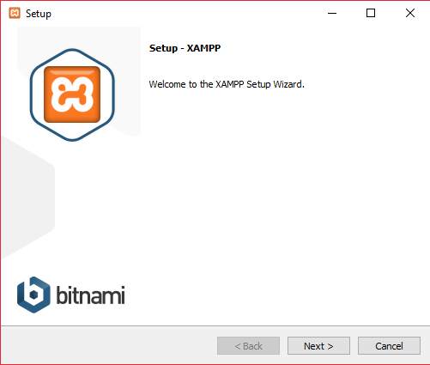
Figure 1: Setup welcome window for XAMPP setup as shown above.
- Follow the instructions on the setup wizard and click next and the following prompt will show up: -
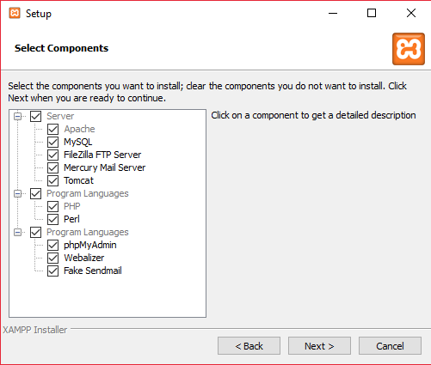
Figure 2: Select components window for XAMPP setup as shown above.
- Hit next again, and set the installation path for XAMPP according to your liking or available storage space in your storage device as follows: -
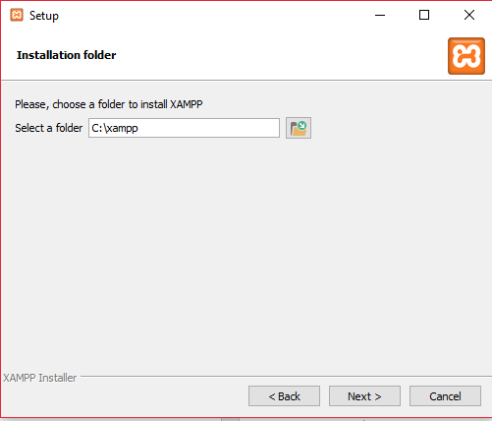
Figure 3: Default installation path to install XAMPP in the setup shown above.
- Hit next and a window will come out asking if you want to learn more about Bitnami, which we will choose not to as follows: -
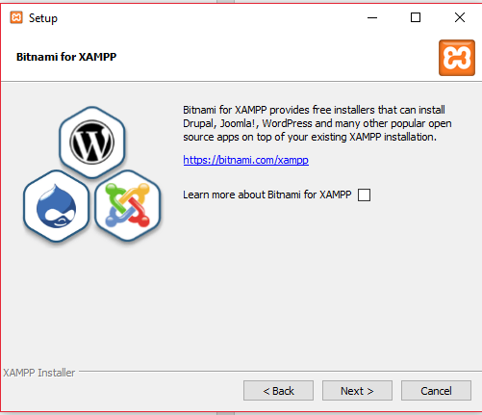
Figure 4: Untick learn more about Bitnami in the XAMPP setup as shown above.

- Hit next two more times to proceed installing XAMPP for windows as follows: -
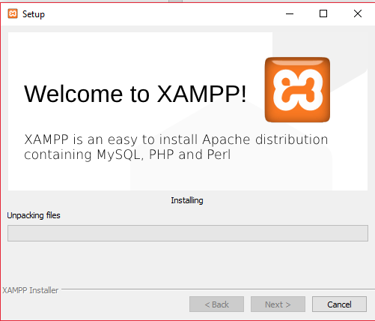
Figure 5: XAMPP installation in progress as shown above.
- When the setup is completed, tick the box asking if you would like to start the Control Panel for XAMPP and hit next.
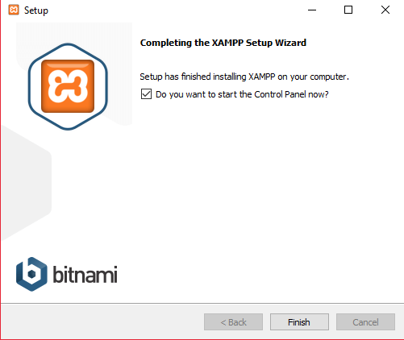
Figure 6: Final window for the setup of XAMPP as shown above.

- XAMPP Control Panel will now open up and you can see 5 different modules that you need to install in order to provide localhost services as follows: -
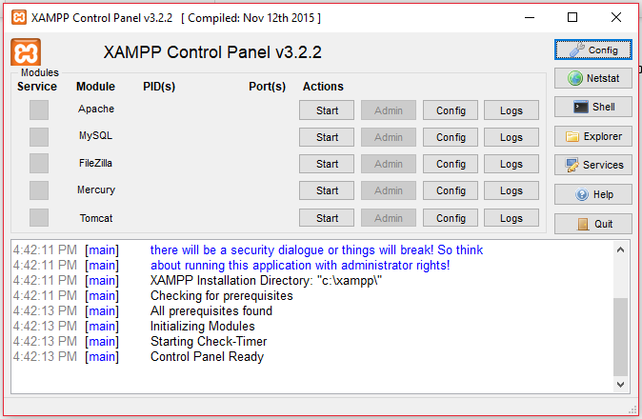
Figure 7: XAMPP Control Panel and the 5 modules as shown above.
- The 5 modules; Apache, MySQL, FileZilla, Mercury, Tomcat are all able to provide localhost services but will only do so after you press start on each one of them and enable them to connect through your network firewall. To do so, just click start, firstly on Apache and the following notification comes up and also tick the box allowing it to communicate through private networks then press “Allow access”: -
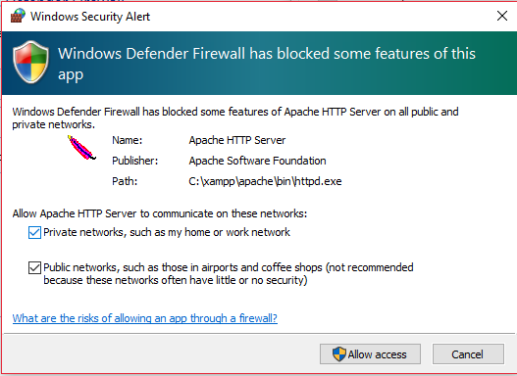
Figure 8: Windows Security Alert to allow Apache to communicate through the firewall as shown above.

- Repeat steps 8-9 for the other four modules; MySQL, FileZilla, Mercury and Tomcat to enable these modules to provide localhost services. The XAMPP control panel should have these services running properly as shown: -
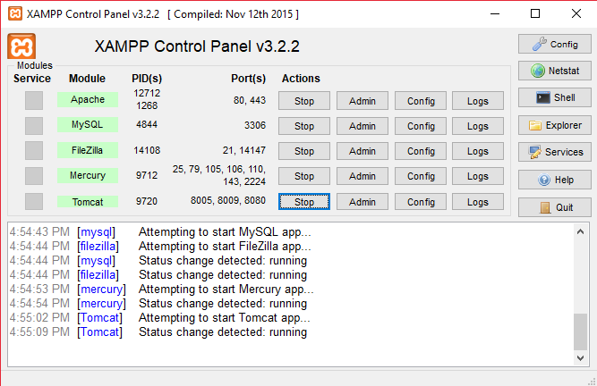
Figure 9: XAMPP Control Panel with the 5 modules running properly as shown above.
The services are running as intended when they have their names highlighted in green as shown in Figure 9 above.
Steps 1-10 have clearly shown how you can install XAMPP and run 5 modules in order to provide localhost services for your machine.

Task 1.2 (Merit 2) – Application of database in localhost
In order to apply a database into the localhost, first one would need to acquire a database file, which in this case would be the database for Fantastic School. Here are the steps to follow for applying a database: -
- Acquire the database files collected in a single folder such as the following:
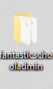
Figure 10: Fantastic School Admin database files as shown above.
- Place the database file within “htdocs” folder in the installation path of your XAMPP application, which in this would be – ThisPC > Acer(C:) > xampp > htdocs as follows: -
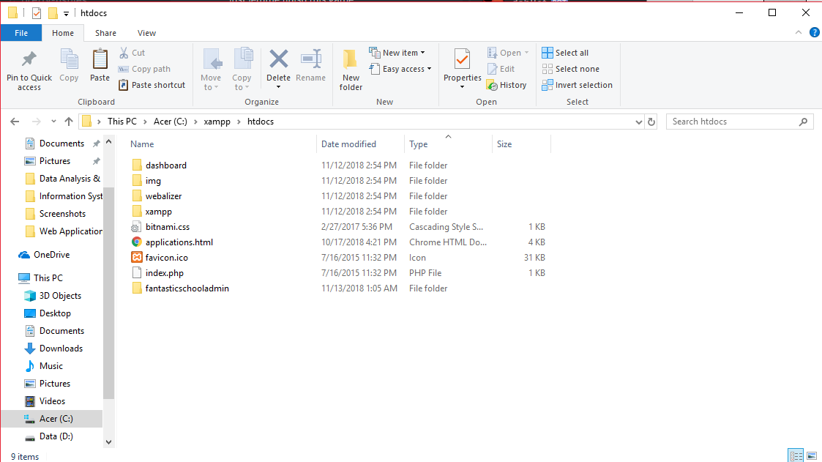
Figure 11: Windows explorer showing that "fantasticschooladmin" has been copied to the target path as shown above.

- After which we open up the XAMPP Control Panel and run only 4 of the modules that will run the database on our localhost services. The 4 modules; Apache, MySQL, FileZilla, and Mercury are to be started as follows: -
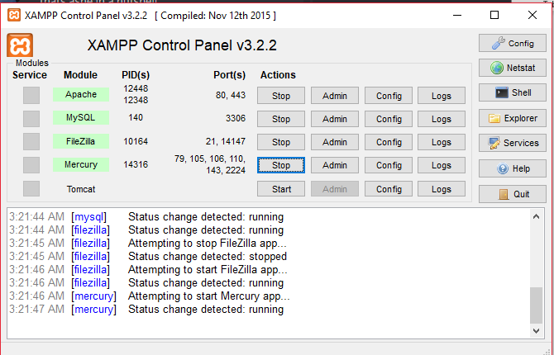
Figure 12: XAMPP Control Panel with the 4 modules started up as shown above.
- Now go to your preferred web browser, in this case being Google Chrome, and type in the addressbar “localhost/phpMyAdmin” and hit enter, the following page will show up: -
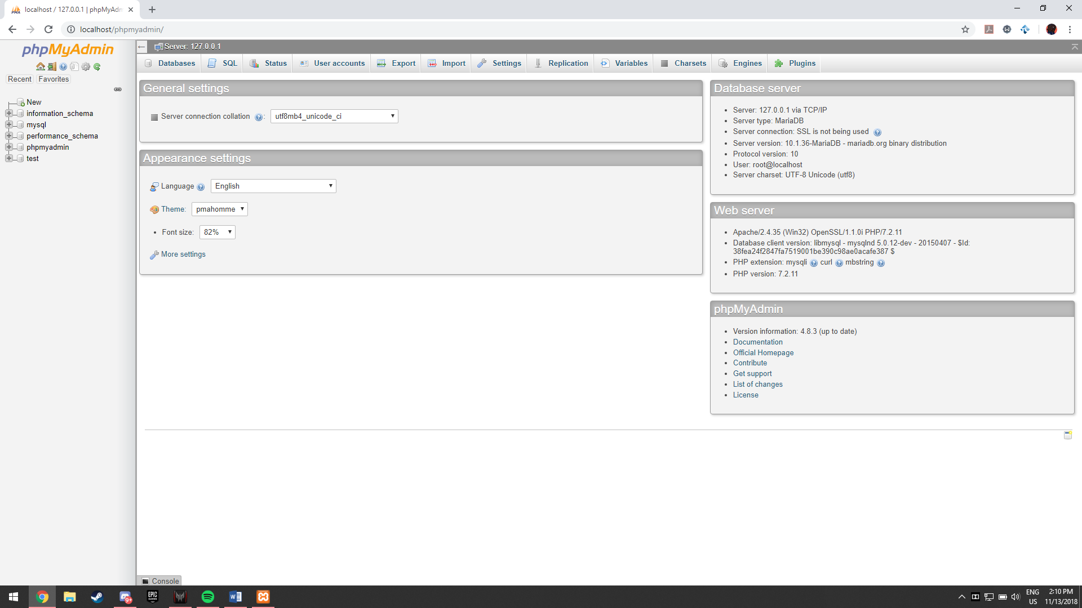
Figure 13: phpMyAdmin in Google Chrome as shown above.

- We now head onto creating the database, we move to the “Databases” tab in phpMyAdmin and set the database name to the name of the SQL previously mentioned which is “fantastic_school_admin_db” making sure it is spelt as is and setting the language to collation (which is set by default) then click ‘create’ as follows:-
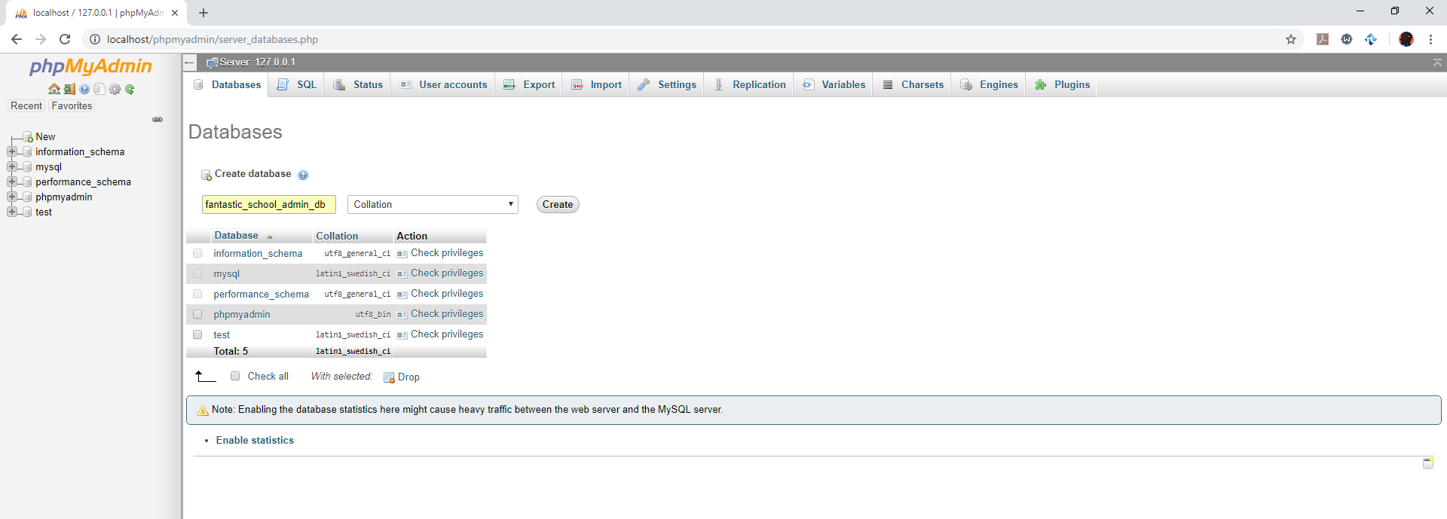
Figure 14: Database creation under phpMyAdmin with create button highlighted in red in Google Chrome as shown above.
- Now head back to htdocs in the XAMPP installation path and the folder “fantasticschooladmin, we are to look for a folder named “INSTALL”, we look for the sql file name which in this case is “fantastic_school_admin_db”, making sure that is case sensitive and spelt properly as follows: -
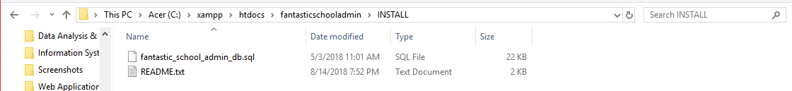
Figure 15: File path and SQL file in windows explorer as shown above.
- Back in phpMyAdmin in Google Chrome, select the tab “Import” as follows: -
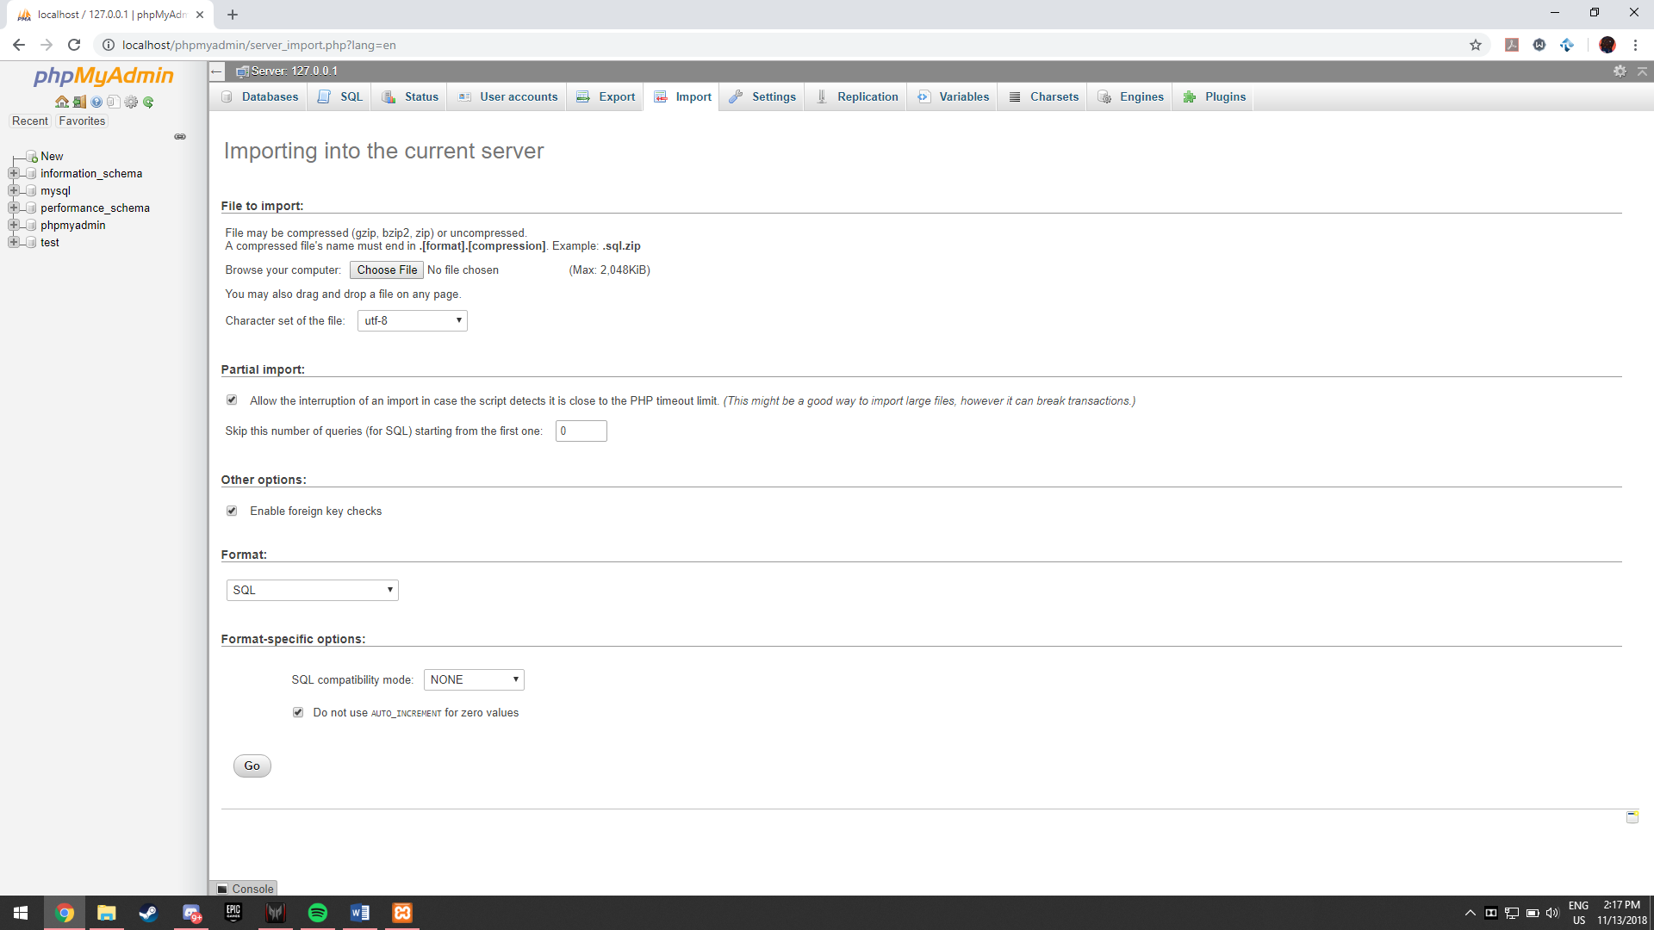
Figure 16: Import tab under phpMyAdmin in Google Chrome as shown above.
- Select choose file and head over to where the previously stated SQL file was saved under htdocs and hit open :-
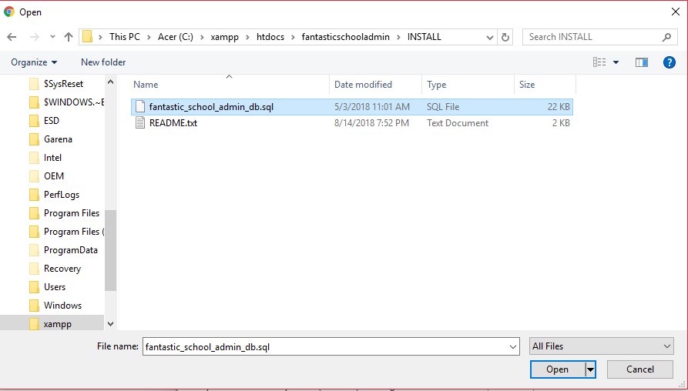
Figure 17: Choose file for importing under phpMyAdmin in Google Chrome as shown above.
- After selecting the file, hit the “Go” button at the bottom of the Import page as shown: -
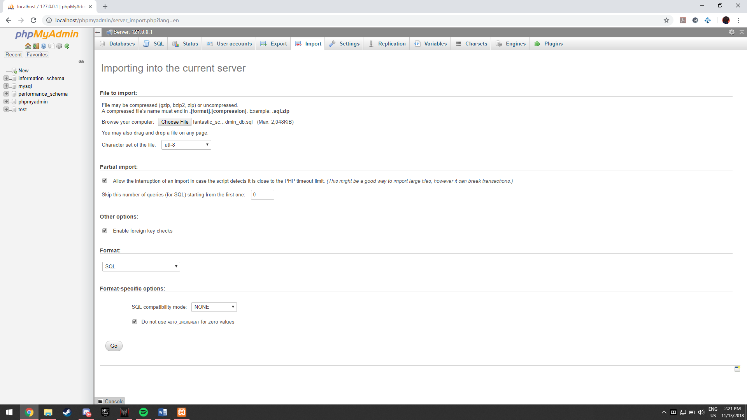
Figure 18: "Go" button highlighted in red under import as shown above.
- A successful import results in the following prompt: -
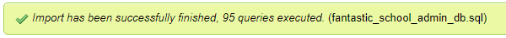
Figure 19: Import successful under phpMyAdmin in Google Chrome as shown above.

- After import, and the page refreshes to show all tables involved in the database as follows: -
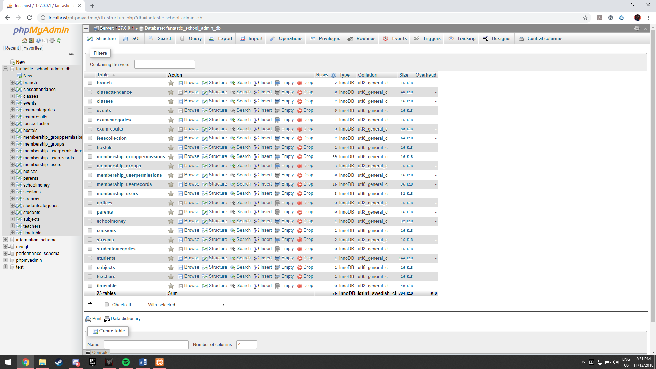
Figure 21: Database tables under phpMyAdmin in Google Chrome as shown above.
- That shows us we have our database successfully implemented into phpMyAdmin, and to test if it actually works, we can visit the database site by entering “localhost/fantasticschooladmin” into Google Chrome’s address bar and hitting enter as follows: -
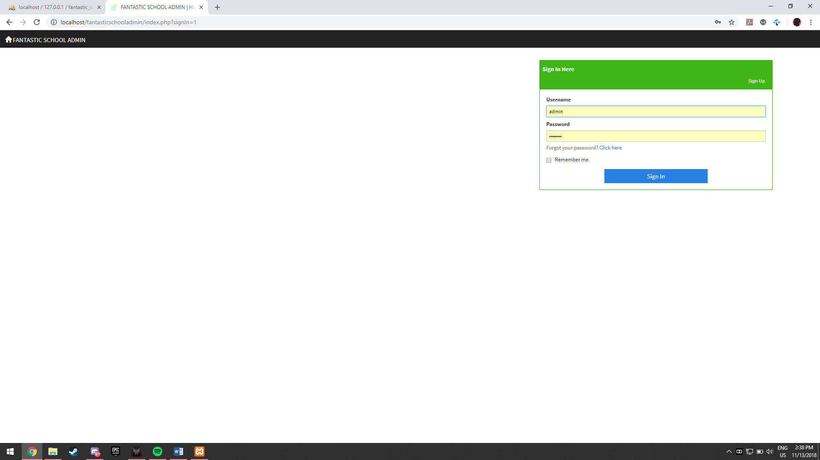
Figure 22: Fantastic School Admin in Google Chrome as shown above.

Task 2 – Implementation of web-enabled database management system

Task 2.1 – Registration on new students and how the database records data
In order to register a new student in the database, we would need to visit the database site under phpMyAdmin as mentioned in a previous task. The following steps are what is to be done if a new student is to be registered under the database: -
- Open Fantastic School Admin database in your local web browser by visting “localhost/FantasticSchoolAdmin” in your web browser : -
Figure 23: Fantastic School Admin login page in Google Chrome as shown above.
- Login with your credentials as an administrator and navigate to the student page : -
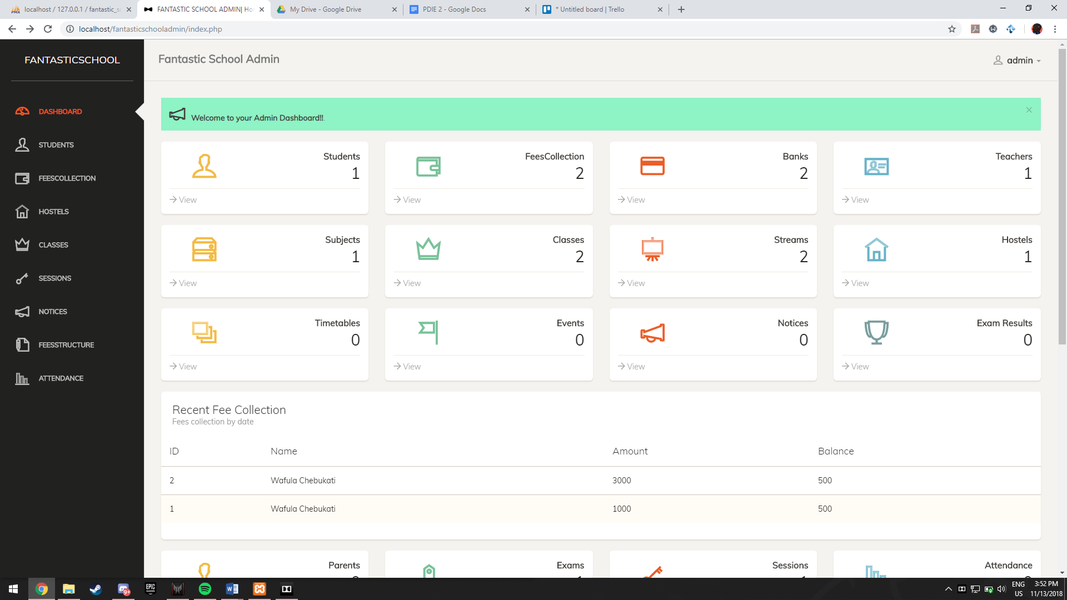
Figure 24: Fantastic School Admin homepage in Google Chrome as shown above.
The user may either click on “Student” on the left hand navigation bar or on the “Student” icon, both of which are highlighted in red.
- Visit the student page and click “ + Add new” in order to register a new student : -
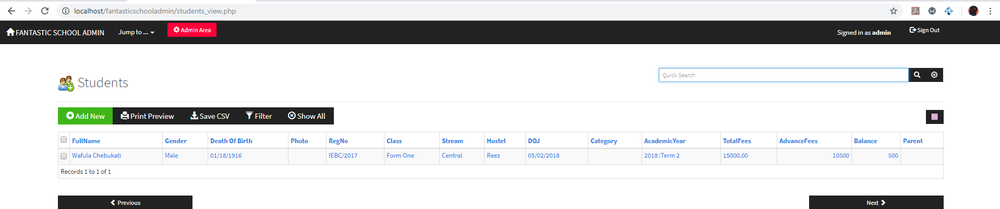
Figure 25: Add New button in the Students page in Google Chrome as shown above.
The button is in green at the top right corner of the table for students, which currently only holds 1 record of a student.
- Fill in the necessary fields when the registration form opens up as follows : -
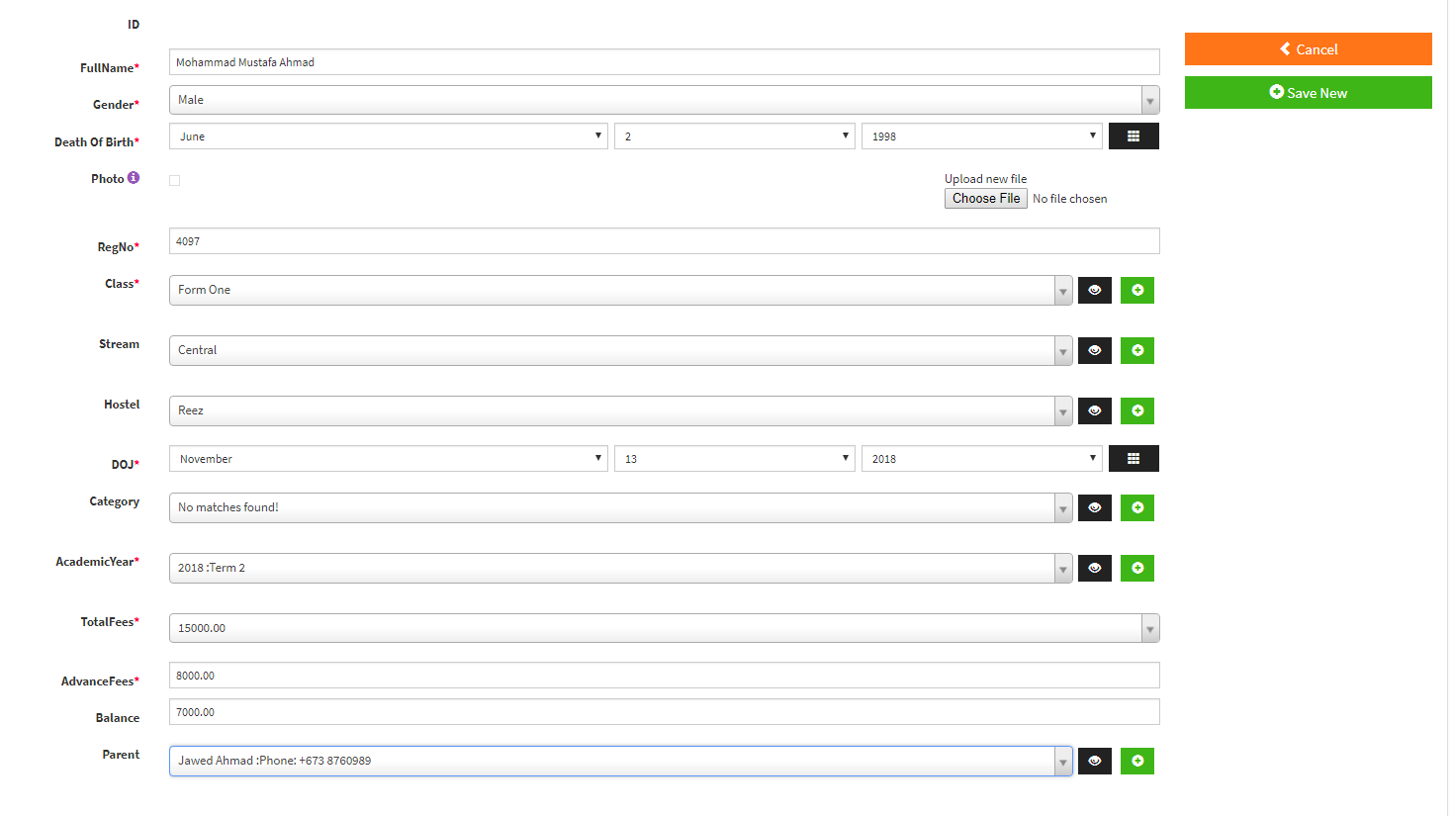
Figure 26: Student registration form with filled in necessary fields as shown above.
- Click “+ Add New” after step 4 and the student record will be saved as follows : -
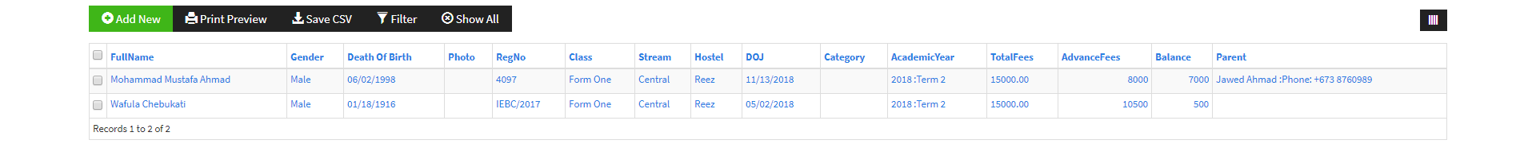
Figure 27: New registered student record shown in the student page as shown above.

Task 2.2 (Merit 3) – Structure of the “Student” table in the database
The structure of the Student table in the database can be viewed through phpMyAdmin, it will be briefly discussed as to what fields are involved and the justification of each datatype.
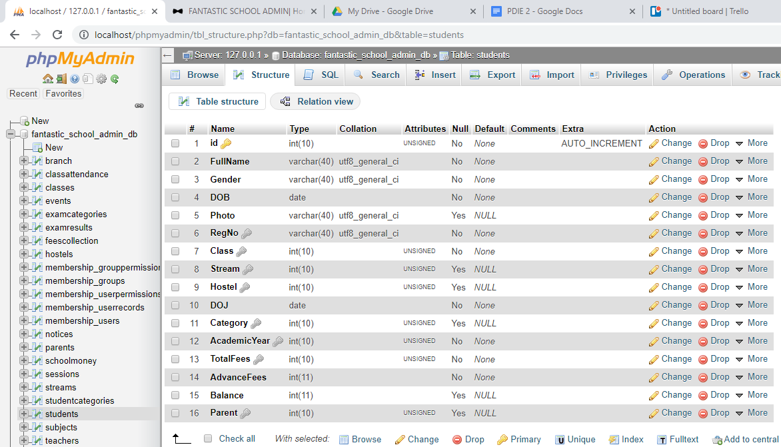
Figure 28: Structure of Student Table under phpMyAdmin in Google Chrome as shown above.
- The ID column is used as a primary key with integer 10 to allow for up to an ID of 10 digits unique for each student record.
- The Full Name column has various characters of up to 40 characters to allow users to enter their full name appropriately.
- Gender column also has various characters of up to 40 characters to allow users to enter their gender accordingly.
- Date of Birth is set to date data type to allow users to only enter a date in this column.
- Photo has been set up to 40 various characters as the photo needs a name to be stored in the database to refer to the uploaded photo file.
- Registration Number up to 40 various characters to allow the system to register a number with letters or special characters unique to each student.
- Class is set to integers of up to 10 digits because it is a foreign key to the class ID referring to which class the student is assigned to.
- Stream is set to integers of up to 10 digits because it is a foreign key to the stream ID referring to which stream the student is in.
- Hostel is set to integers of up to 10 digits because it is a foreign key to the hostel ID referring to which hostel the student is staying in.
- DOJ (date of join) is set to date to allow users to only enter a date of when the student joined the school.
- Category is set to integers of up to 10 digits because it is a foreign key to the category ID referring to which category of students this student is in.
- Academic Year is set to integers of up to 10 digits because it a foreign key to the academic year ID referring to which year the student is in.
- Total Fees is set to integers of up to 10 digits as it allows the user to enter a large sum amount of money in numbers.
- Advance Fees is set to integers of up to 11 digits as it allows the user to enter a large sum amount of money larger than total fees in order to pay in advanced in numbers.
- Balance is set to integers of up to 10 digits to allow users to show how much of their fees is left in numbers.
- Parent is set to integers of up to 10 digits because it is a foreign key to the parent ID referring to which parent is associated with the student record.

Task 2.3 (Distinction 2) – 5 modules in XAMPP and their role in providing localhost services
There are 5 modules that exist within XAMPP to provide localhost services to run a fully-fledged desktop server, the 5 are; Apache, MySQL, FileZilla, Mercury and Tomcat.
Apache
(All information and research made in this section of the assignment is referenced to (Eftaiha, 2012))
Apache is an HTTP server program or software which runs in our background under your operating system that allows multi-tasking and provides services to applications that connect to it is such as our web browsers. Servers are offered through services that the client uses such as various protocols running on different ports; by default the Hypertext Transfer Protocol (HTTP) runs on port 80, Simple Mail Transfer Protocol (SMTP) running on port 25, Domain Name Service (DNS) that maps the DNS of the site to the set IP address/es run on port 53, File Transfer Protocol (FTP) used for transferring files through uploading and downloading runs on port 21.
MySQL
(All information and research made in this section of the assignment is referenced to (MySQL, 2018))
MySQL is an open source application or software for web development which creates database for websites. SQL works as a database management system that structures collections of data. This allows for a website to have a shopping list, galleries or even adding records of transactions and users. The service is offered through the MySQL protocol under the default port 3306, used by the MySQL client which in this case is XAMPP, the MySQL connectors, “mysqldump” and “mysqlpump” are using this port.
FileZilla
(All information and research made in this section of the assignment is referenced to (Upjohn, 2011))
Filezilla in XAMPP allows for the server to receive and send out data. It is basically the file transfer protocol for the website and allows any authorized FTP (File Transfer Protocol) clients to connect the server in order to send or receive files (download and upload). No graphical user interface is issued for FileZilla other than being able to see what you upload and download from the server. The interface is only provided on the client side of the FTP. FileZilla enables the File Transfer Protocol on port 21 by default and SFTP (Secure File Transfer Protocol) through port 22 by default.

Mercury
(All information and research made in this section of the assignment is referenced to (Chris, 2012))
Mercury is mail package in XAMPP specifically for Windows that allows you to start sending emails through your server, it utilizes POP3, IMAP and SMTP (Simple Mail Transfer Protocol) in order to be able to issue e-mails through your server or receive them as well. Basically Mercury allows the server running under XAMPP to locally send e-mails in packages to other clients or users of the server. Port 25 is used for POP3 by default, port 79 for IMAP by default and port 105 for SMTP by default. This allows mail services to be issued locally.
Tomcat (Apache Tomcat)
(All information and research made in this section of the assignment is referenced to (Apache Tomcat®, 2018))
Similar to Apache, Tomcat is an open source version of Java Servlet, JavaServe Pages, Java Expression Language and Java WebSocket technologies. This allows for a Java language based version of Apache to run on the server allowing for Java elements to run in the server as having Java allows for cross-platform use of the server that caters to any other operating system, not just between Windows and Mac users as they are the two largest groups. Port 8080 is used for HTTP (Hypertext Transfer Protocol) by default, port 8443 is used for HTTPS (Hypertext Transfer Protocol Secure ) by default, and lastly port 8009 used for the “AJP/1.3” made by tomcat themselves is set by default. This allows for the same thing Apache does, but with implemented Java elements under no cost.

Task 3 – Validation and Error Handling
Error handling of the database for student registration under a new account can be found under 2 files that are associated with each other. These files are located within the fantastic school admin database file, under the php file “students_dml.php” and the CSS style sheet “bootstrap-theme.css”. The PHP file is in the main folder of the file whilst the CSS style sheet is under resources/intializr/CSS path. We shall open these two files in order to view them in notepad++ as follows: -
PHP file
Under the PHP file, we look under the lines 8-133 where a repeated validation and error handling code is used. Here are the code lines: -
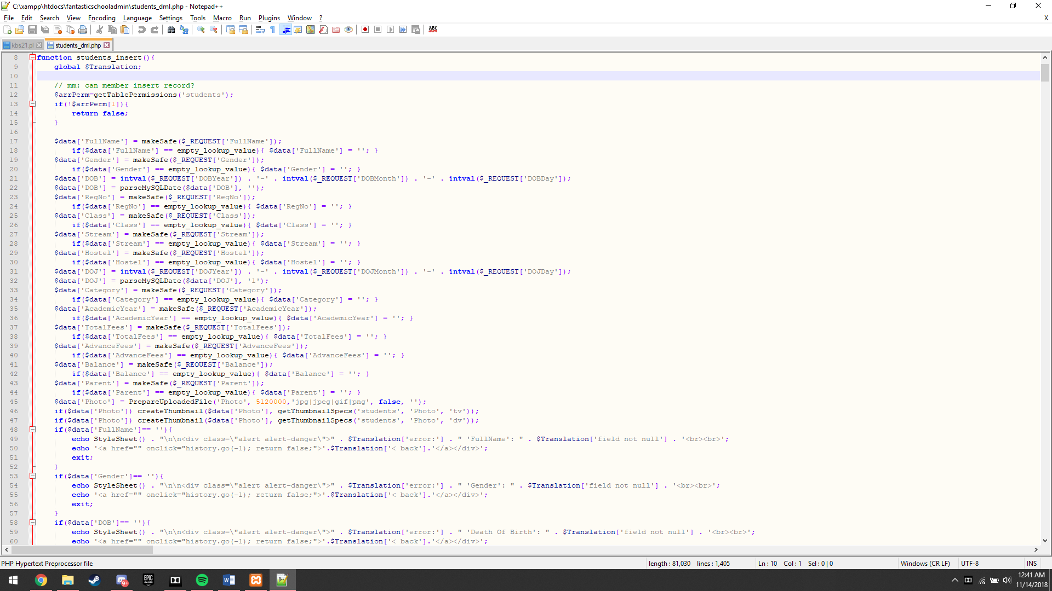
Figure 29: Notepad++ showing lines 8-60 of the students_dml PHP file as shown above.
Throughout lines 18-47 the code “empty_lookup_value” is used which validates whether the field has been empty or not and that the value will be looked up in order for it to be validated for its datatype, such as the lines 21-22, which requests for the Date of Birth (DOB) of the student and checks if the value entered was indeed a date data type. It goes on and on until like 47 for each field required for registering the student.

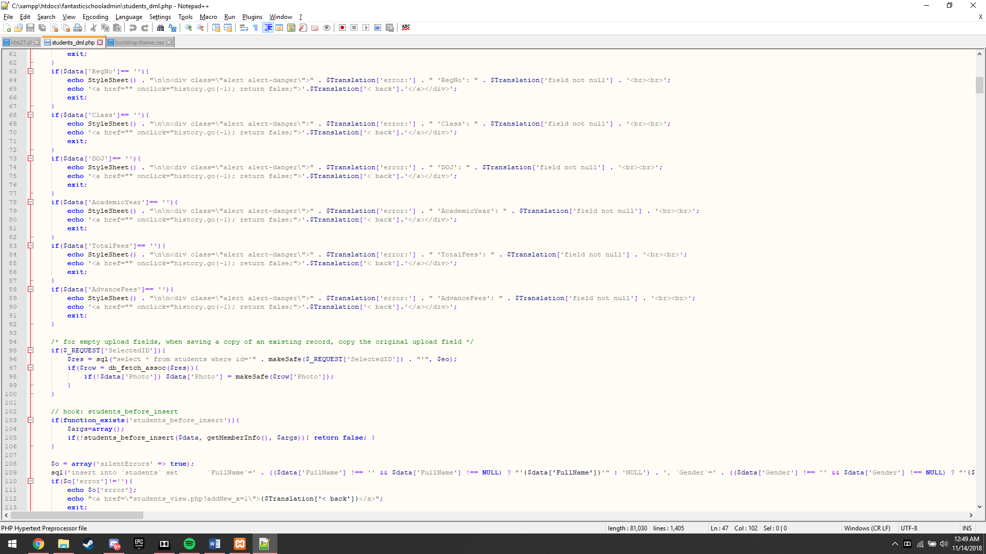
Figure 30: Notepad++ showing lines 61-113 of the students_dml PHP file as shown above.
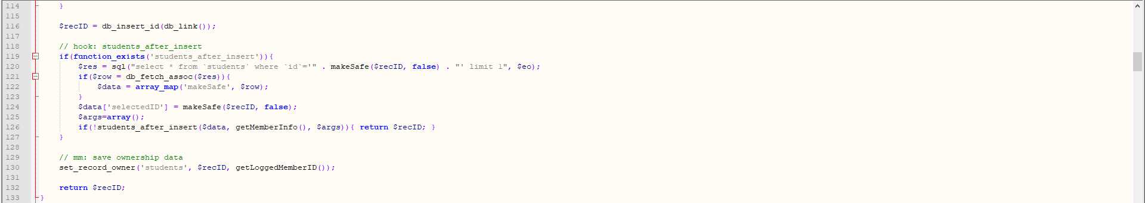
Figure 31: Notepad++ showing lines 114-133 of the students_dml PHP file as shown above.
From the above screenshots specifically from lines 48-92, the div class “alert alert-danger” which is a class called from the CSS style sheet is an error handling mechanism implemented in the system.

To further explain how this works, we look at the “alert alert-danger” div class under the bootstrap-theme CSS style sheet as follows: -
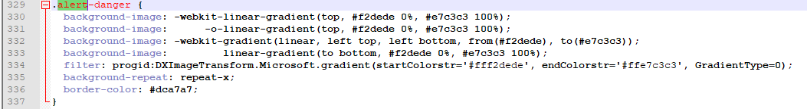
Figure 32: Notepad++ showing lines 329-337 of the bootstrap-theme CSS style sheet as shown above.
As shown above, a notification or pop-out is made when an invalid or empty necessary field is left when registering a new student. Styles are implemented and color coding is applied then called upon in the PHP file to prompt the user to either enter a valid input or key in a missing field’s data.

Task 4 – Review and Test web-enabled database management system
The software used for testing the web-enabled database management is TestComplete software used for software testing in general but also has built-in web testing tools. Here are the steps to make a valid test run: -
- Run TestComplete and add a new project:-
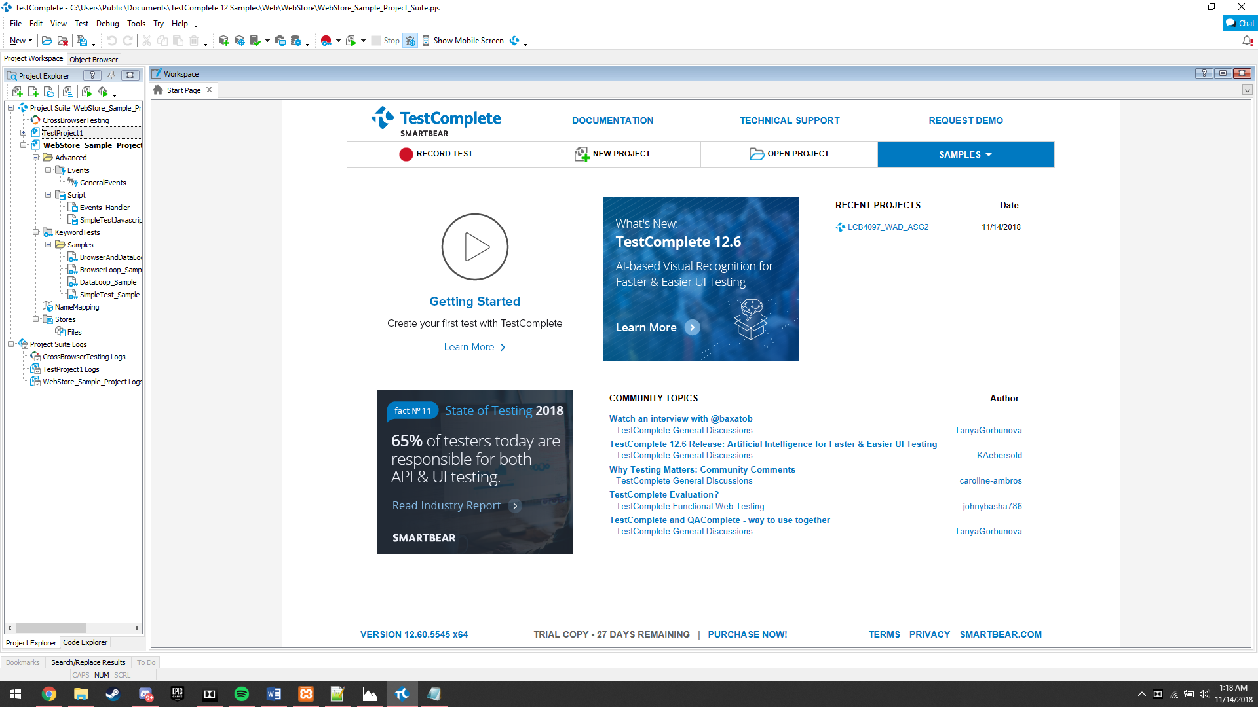
Figure 33: TestComplete and Add New Project button highlighted in red as shown above.

- Add an appropriate project name and location to save the project, in this the project will be named “Fantastic School Admin” and saved under the default location path then hit next: -
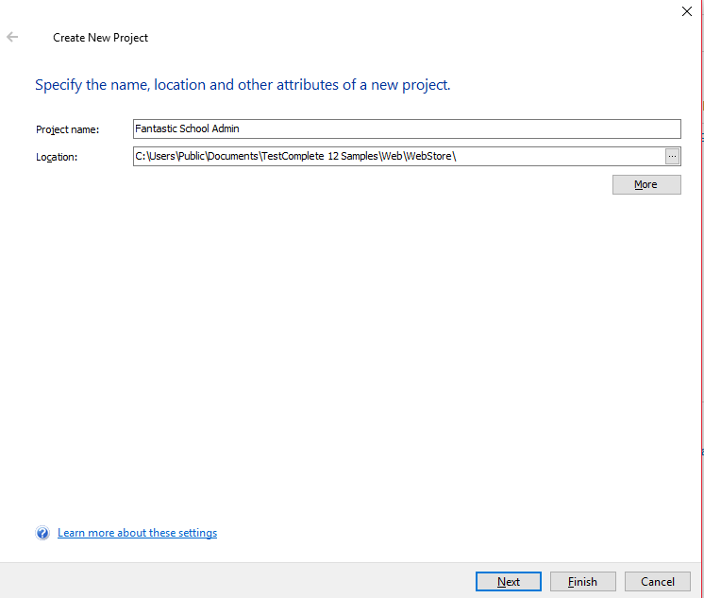
Figure 34: TestComplete project name and location as shown above.
- Choose “Functional testing of web pages” as we are doing a web test and hit next: -
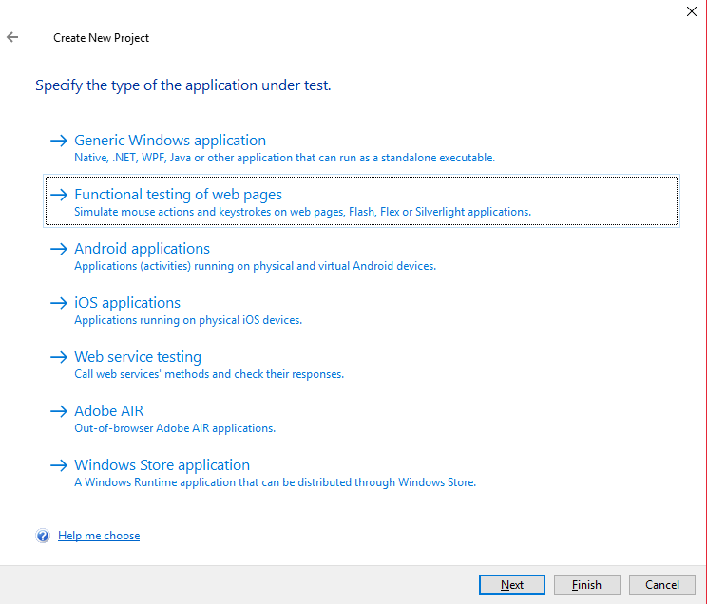
Figure 35: TestComplete application of test as shown above.

- Choose your preferred scripting language, in this case we shall choose “Javascript” and hit finish as follows: -
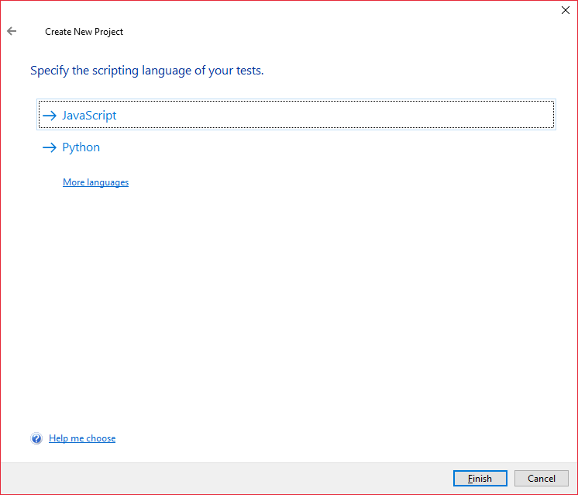
Figure 36: TestComplete and selection of scripting languages as shown above.
- Click Record New Test as follows: -
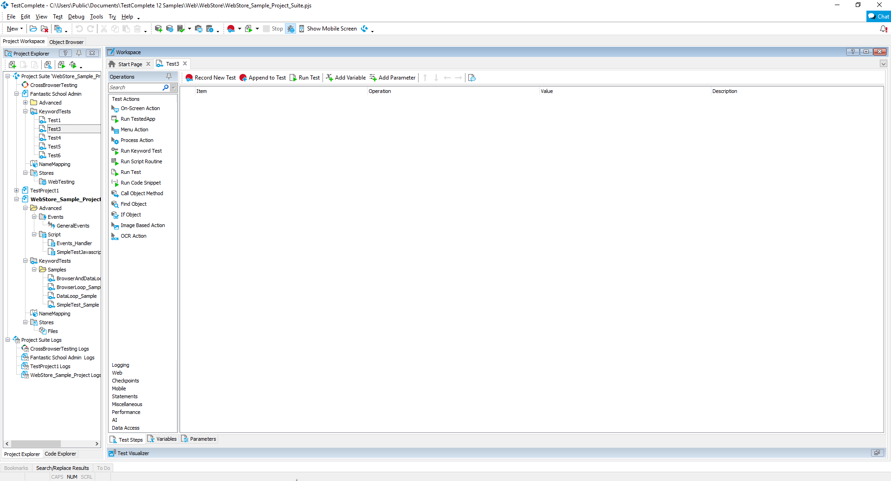
Figure 37: TestComplete and record new test button highlighted in red as shown above.

- A new widget appears in the window, a recording tool and make sure it is recording as shown: -
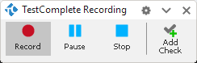
Figure 38: TestComplete recording widget recording as shown above.
- Run Google Chrome and make sure that XAMPP is already running the 4 modules as stated in a previous task, the first 4 modules; Apache, MySQL, FileZilla and Mercury.
- Navigate to the fantastic school admin site by entering “localhost/schooladmin” in the browser address bar and hit enter as shown below: -
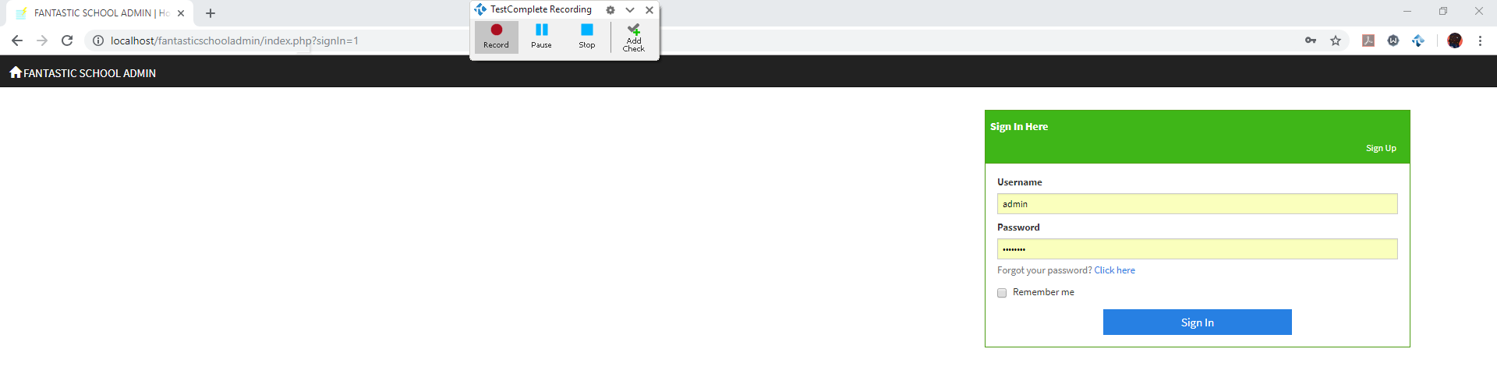
Figure 39: TestComplete recording Google Chrome visiting Fantastic School Admin site as shown above.

- Sign in and when navigated to the homepage, visit the student table as shown : -
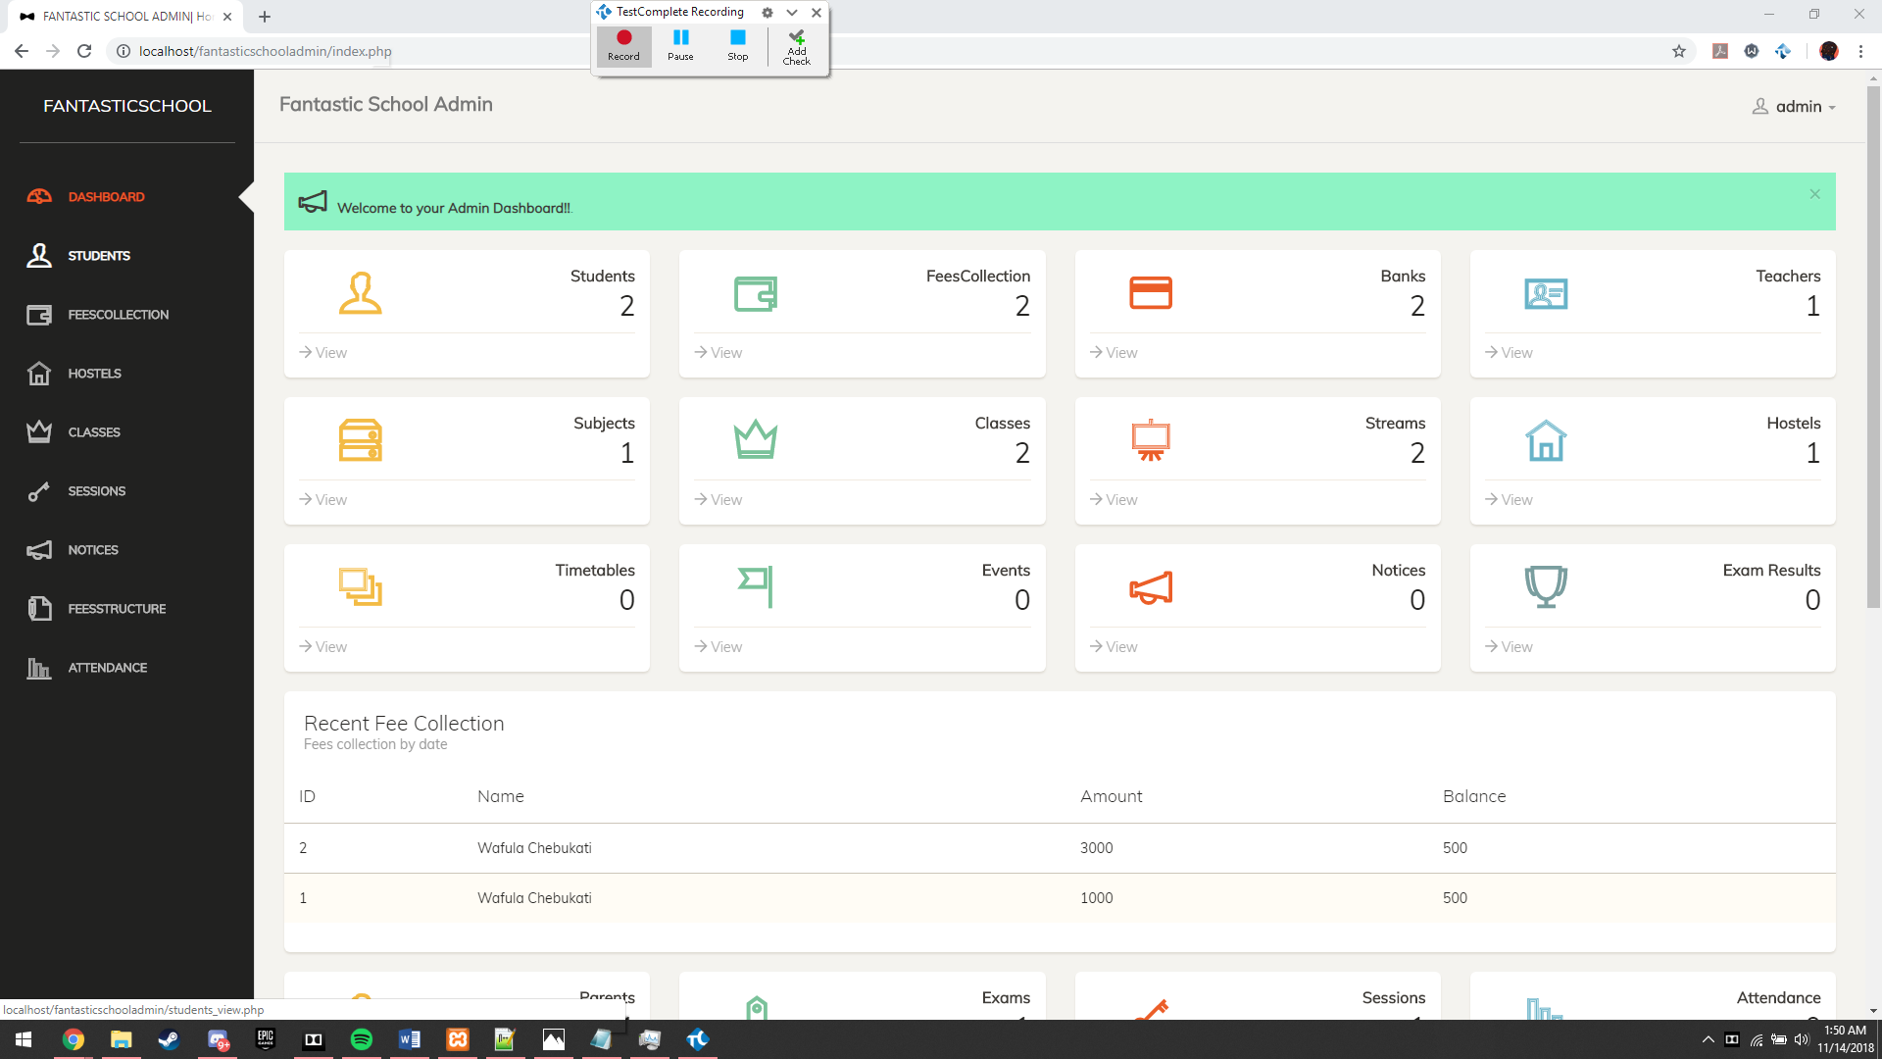
Figure 40: TestComplete recording the homepage and clicking of the student table as shown above.
- When already navigated to the student page, we hit “ +Add Check” for a checkpoint and the following prompt is shown: -
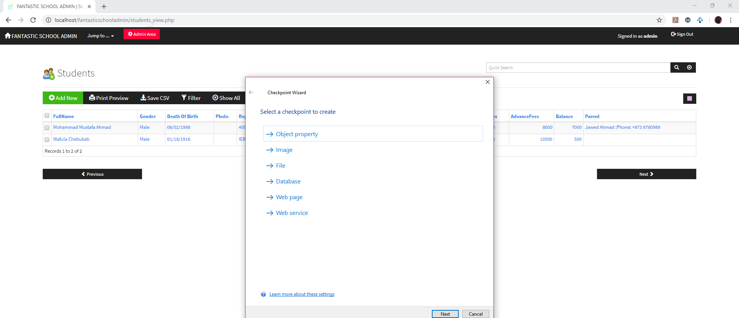
Figure 41: TestComplete Checkpoint Wizard window on the student page as shown above.

- Select Object Property in order to test an object’s property such as its data and data type and hit next, the following window comes out: -
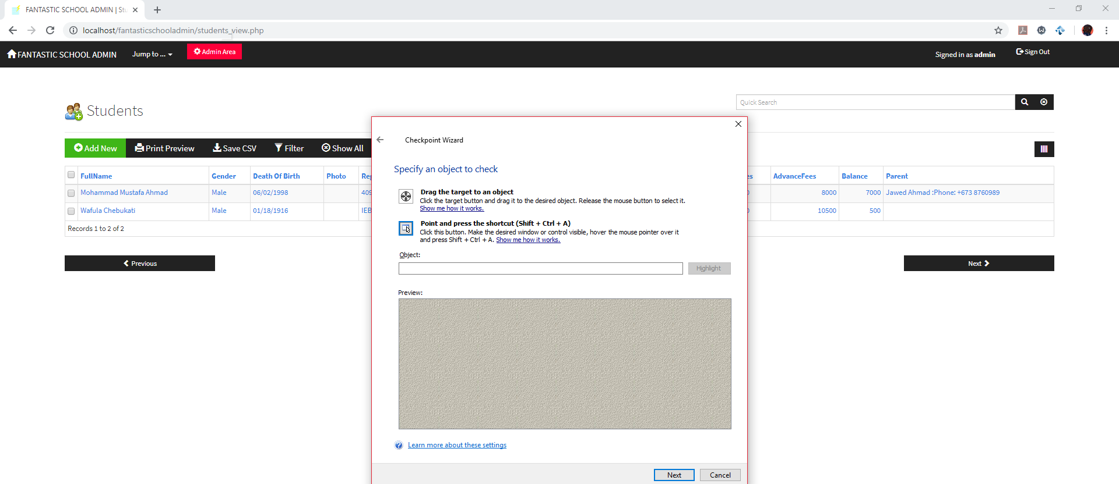
Figure 42: TestComplete Checkpoint Wizard object selection for student page as shown above.
- Now as the above window says drag the small crosshair and target the value you wish to identify, in this case we shall test the DOJ (Date of Join) for the student as follows: -
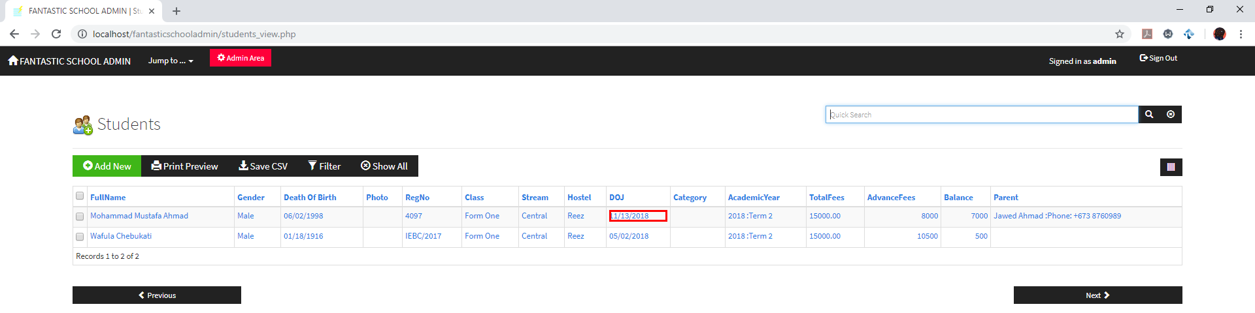
Figure 43: TestComplete drag to object highlighted as shown above.

- The following window will come out verifying that the object is what the user intended on running a test, simply click next as follows: -
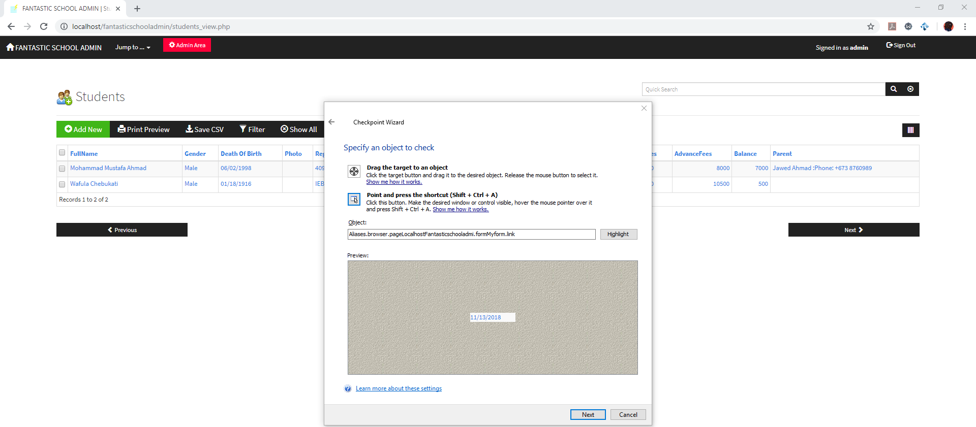
Figure 44: TestComplete Checkpoint Wizard object selected as shown above.
- Click next on the next field but make sure the value is set to “True” to ensure that the data is valid and click finish as follows: -
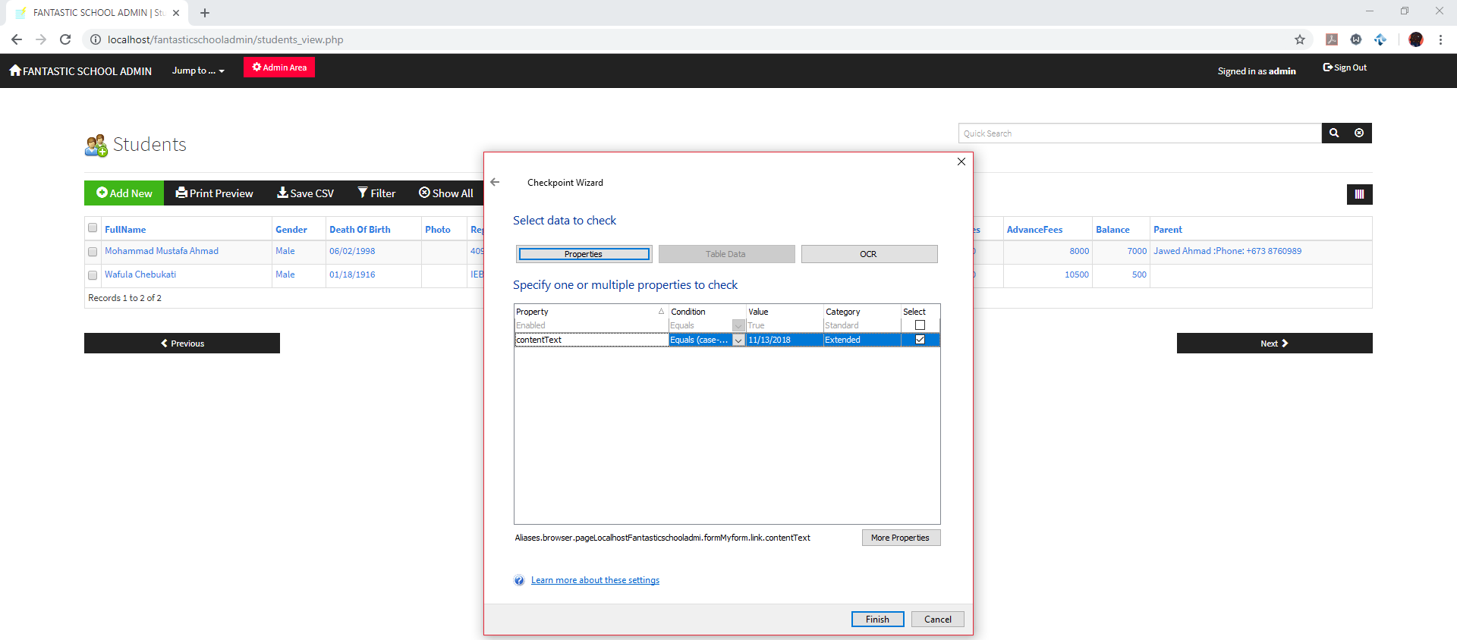
Figure 45: TestComplete Checkpoint Wizard showing that the object value is true as shown above.
- Finally, sign out from fantastic school admin close the browser down and hit “Stop” on the recording tool as follows: -
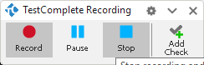
Figure 46: TestComplete Recording Stop button as shown above.
- TestComplete will compile all actions made by the user as follows: -
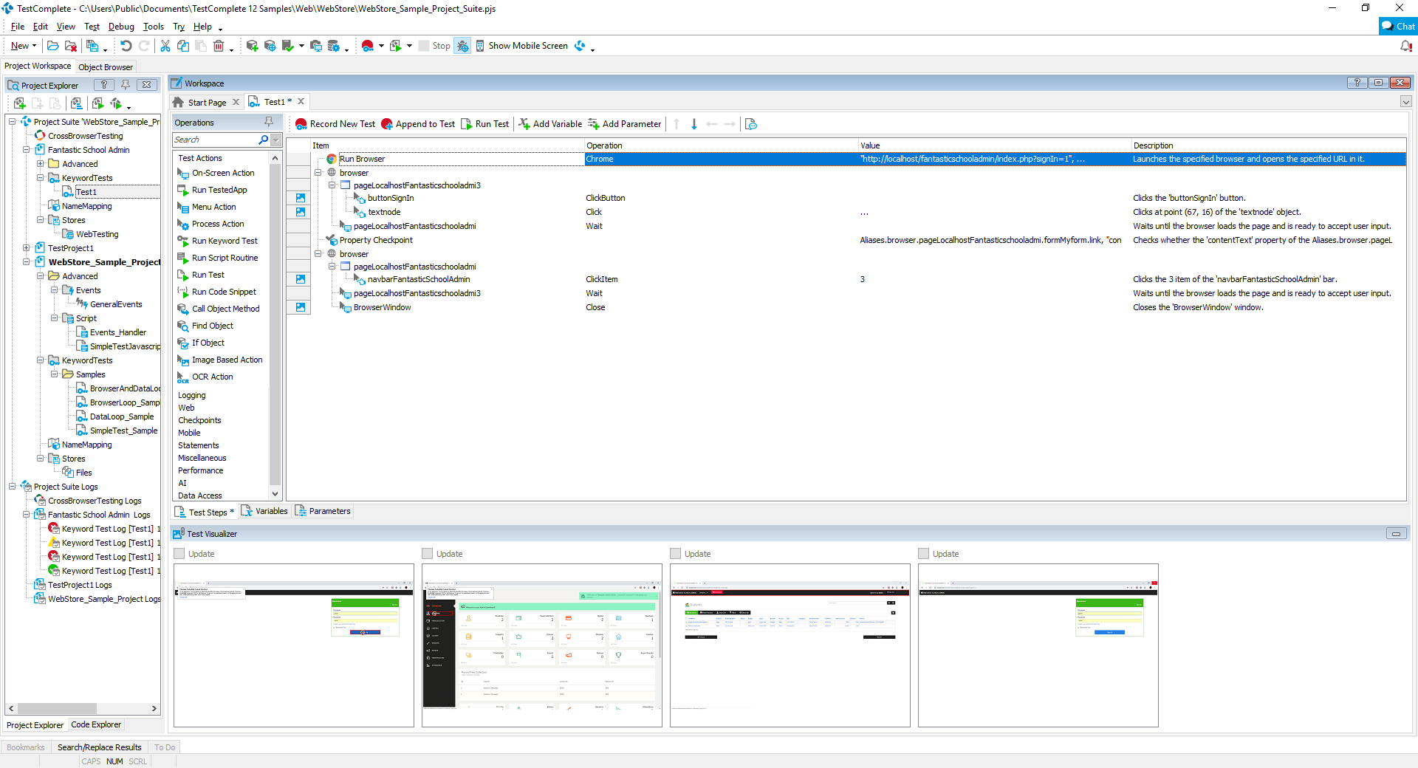
Figure 47: TestComplete showing all user actions in the test run as shown above.
- Save the test and you have made a test for your web application!

Task 5 – Actual Test Results
In order to gain actual test results, we must open up the previous test made. And hit “Run Test” as follows: -
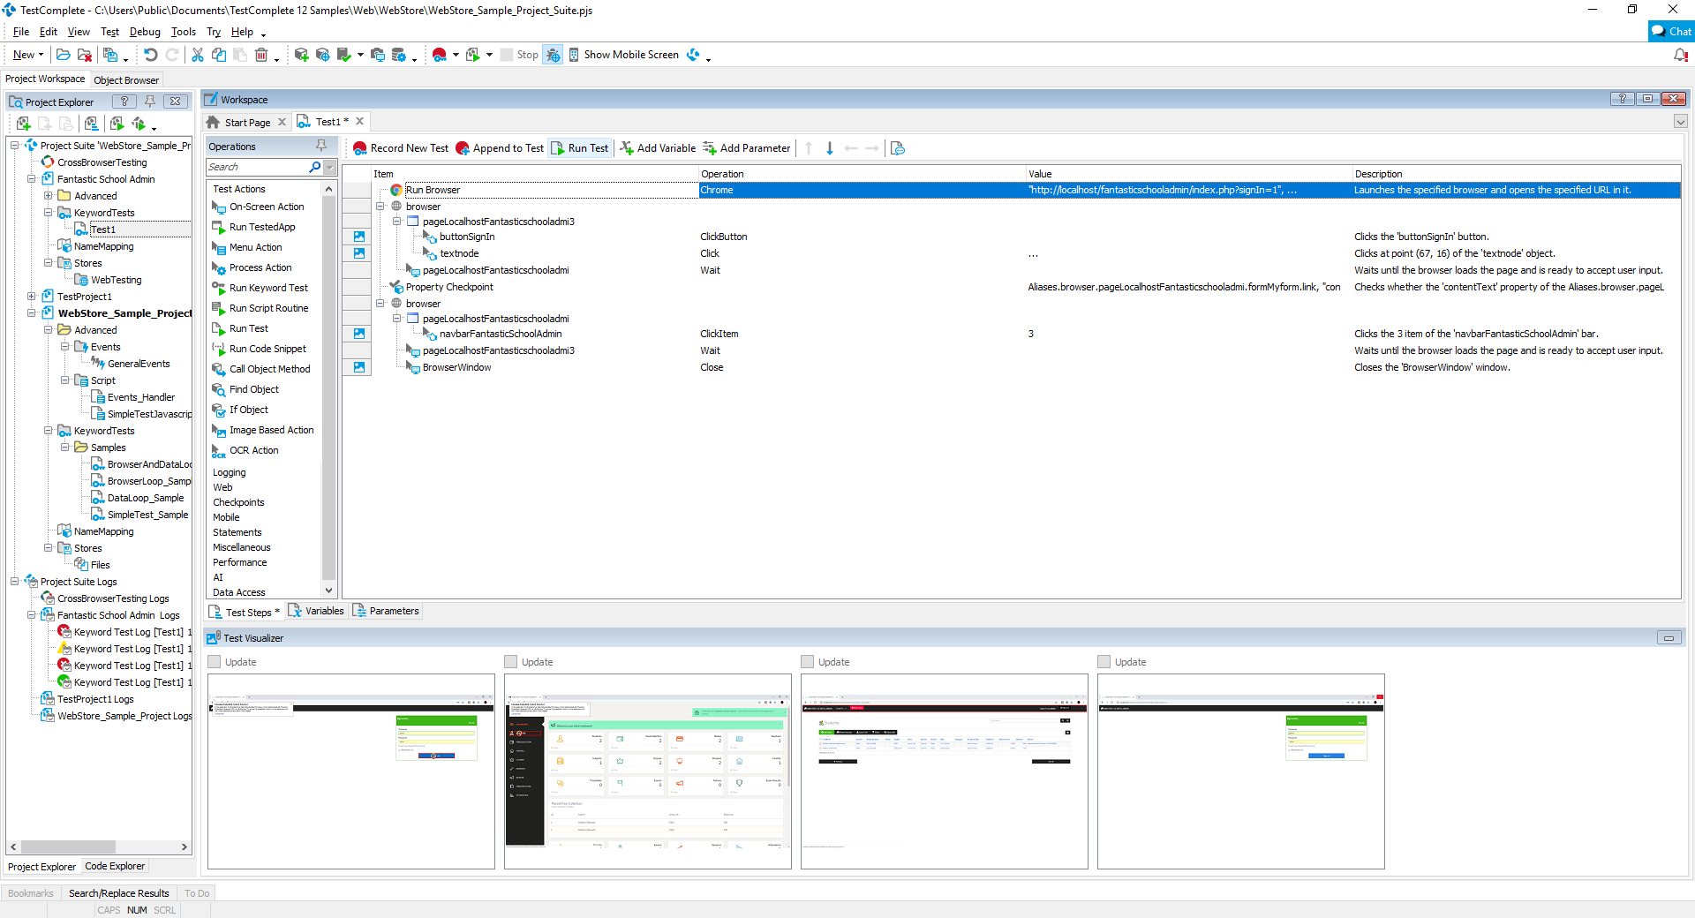
Figure 48: TestComplete run test button highlighted in red as shown above.
After clicking run test, here are the results we have obtained: -
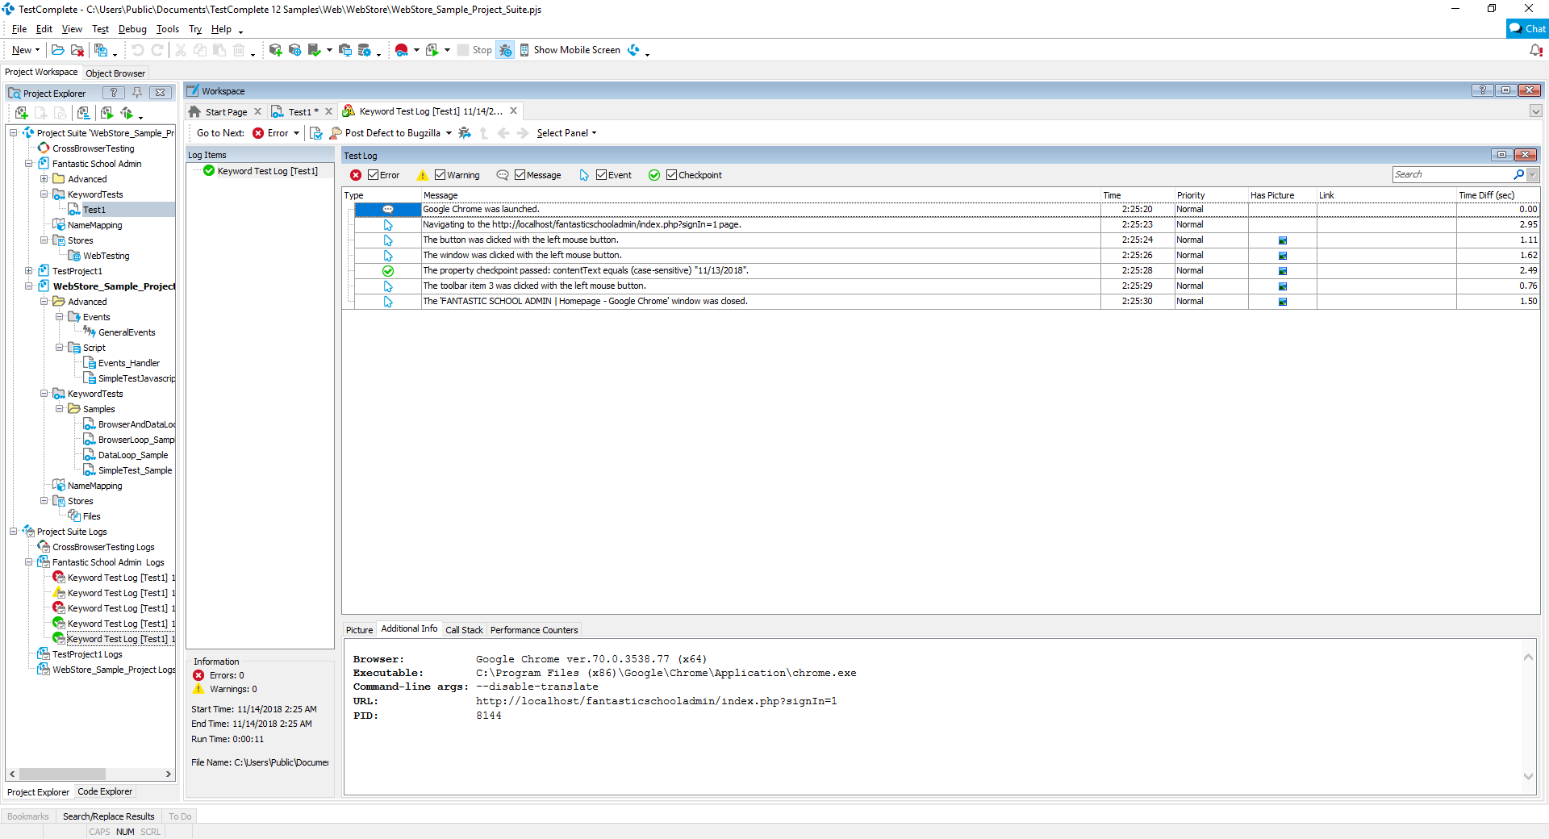
Figure 49: TestComplete test results as shown above.

As you can see from figure 48, we have successfully run the test of testing our website without stumbling upon any errors or warnings, meaning that the site is capable of doing these things and that the data selected was indeed valid.

Task 6 – Suggestion and recommendations on improvements of system

Task 6.1 – Suggestions for improvement on current circumstances
Upon navigating and testing the system, there are 3 suggestions for improvement for the current way the system has been implemented, which are as follows: -
- Transaction records history
Transactions in the database system do not have records of previous transactions, only the total amount of the school fees, the advanced fees which are fees that have been paid and the balance showing what amount is left to be paid. We can see this in the students table as follows: -
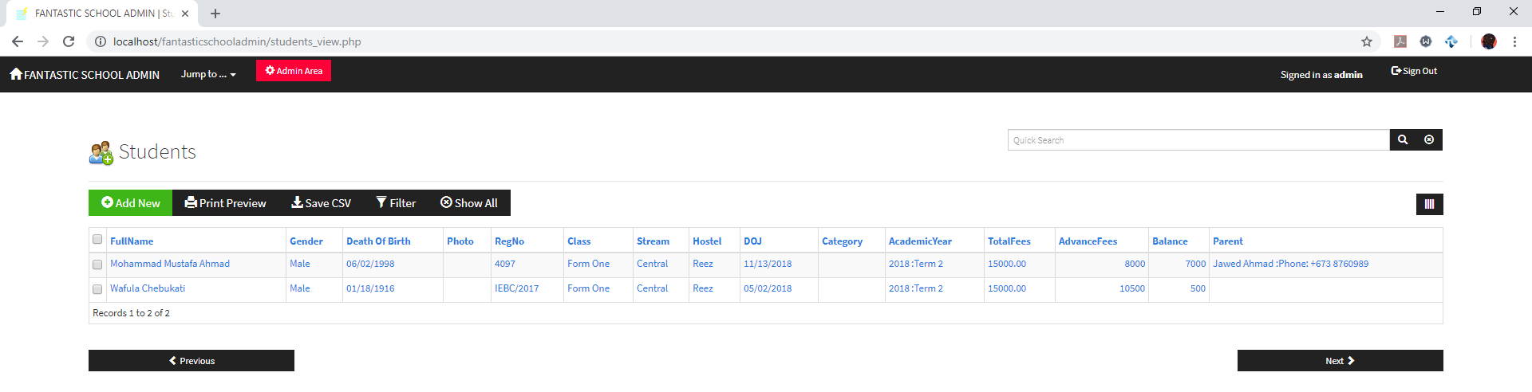
Figure 50: Students table records in Google Chrome as shown above.
We can improve this by adding an option to expand a view on their transactional records and to be able to update transactional records based on how much they pay be it, instalments or through monthly payments, updating the balance automatically.
- Sorting records according to categories
In the case that a table has a lot of columns and the browser lets you scroll through the sidebar, instead of having to, we should be able to sort through a record or look through records by searching the student ID or categorizing the students by their groups. For example if we view the students table in a minimized window as such: -
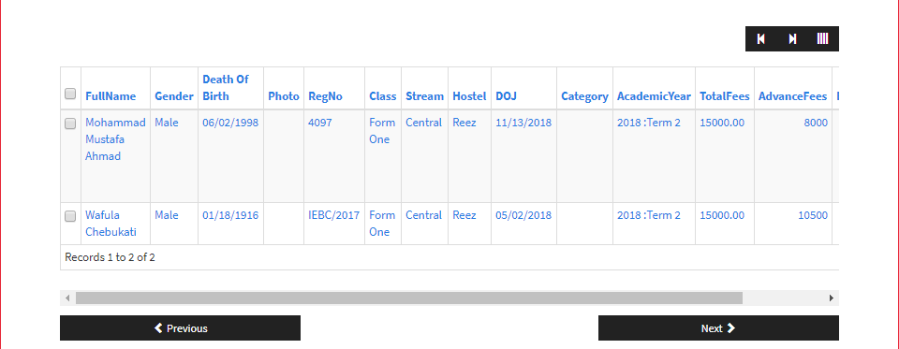
Figure 51: Student table records not being able to view all columns in minimized Google Chrome as shown above.
As you can see the table cannot be viewed properly but if it were to be categorized by a field that holds a group of students such as the student category or stream, we can view this as the column is filtered out and the students are grouped accordingly.
- Navigation
It is a standard for websites to have a global navigation bar and the fantastic school admin site does not contain one besides the one in the homepage, when visiting other pages such as the student page, there is a navigation button, however this is not as user friendly or appealing to users, the button looks as such: -
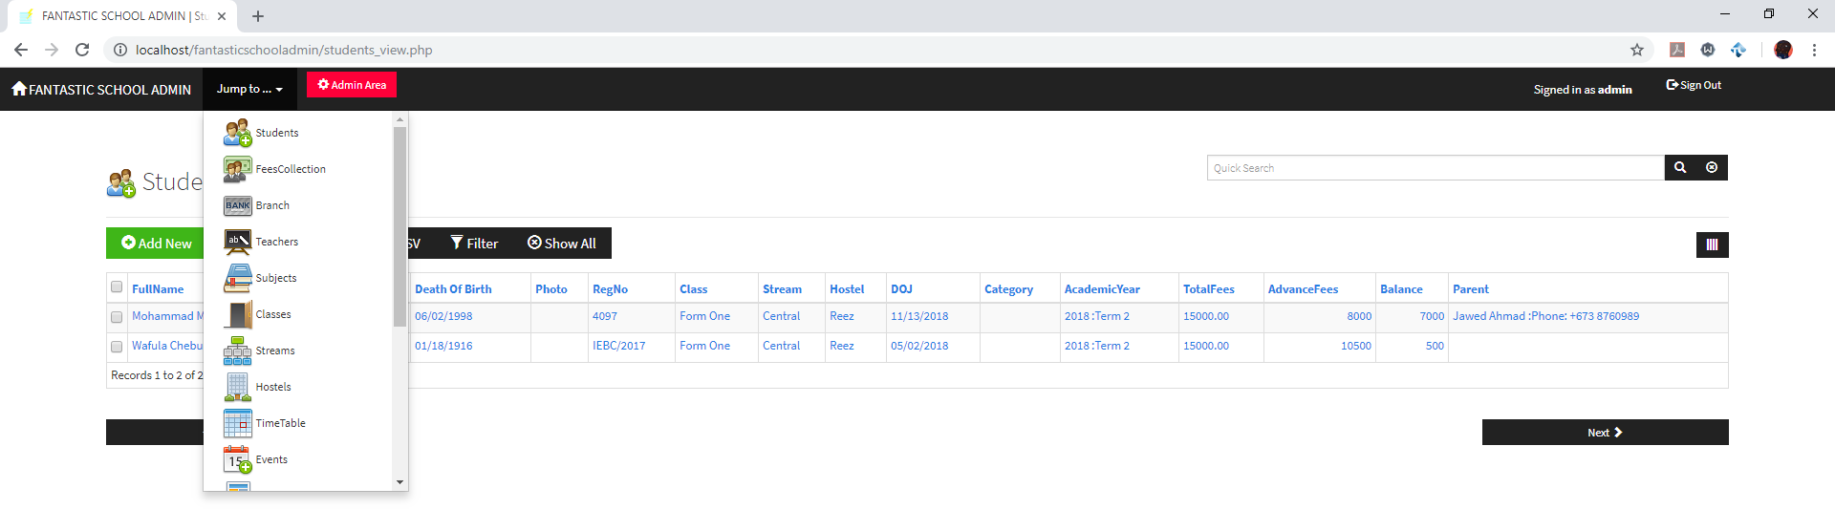
Figure 52: Jump to button in the header of the website in Google Chrome as shown above.
As you can see, the above figure shows us that indeed a navigation is needed to be implemented to allow the users to navigate freely and easily without having to scroll through a selection of pages.

Task 6.2 (Distinction 3) – Propose modern technologies
There are to be 3 proposed modern technologies, the following are the modern technologies: -
- Online banking system
For students from abroad or local students alike, it would be much easier if there was online banking system that allowed their parents to pay through the site instead of having to mail, visiting school grounds or using bank transfers to pay the school. Allowing an online banking system would allow easier tracking of payments as well as it is automatically registered into the database once a transaction has been made, also this means it is cost friendly for parents abroad in terms of travel expenses and bank transfer charges as well.
- SMS Notification system
An SMS notification system is to be made for parents specifically, as using e-mails is redundant as people typically don’t scroll through their e-mail on daily basis, it is much closer to a weekly basis. The SMS notification automatically sends a message to the parent of a student if the student does the following:-
- Attains a grade from an examination, whether passing or failing
- Skips class or is absent without notice
- Is found breaking school rules
- Has not paid school fees
- Upcoming school events
- Achieved an award in school
It would be very convenient to keep parents up to date with the progress of their child in school and so, a notification system through SMS should be implemented.
- QR Code attendance system
An attendance system opposed to manual attendance taking by teachers, a webcam is to be placed in class to scan the student’s QR code via their mobile phone or an issued ID card, this allows for teachers to know who is truly in class and removes the possibility of a student signing the attendance sheet on behalf of a friend. This allows the system to be up to date with who is in class and who is not and works well with being able to notify the parents through the SMS system stated previously if their absence was without any prior notice.

Task 7 – User guide
- Run XAMPP initialize four services as shown in previous tasks and visit localhost/fantasticschooladmin in your local web browser.
- Login with credentials as shown: -
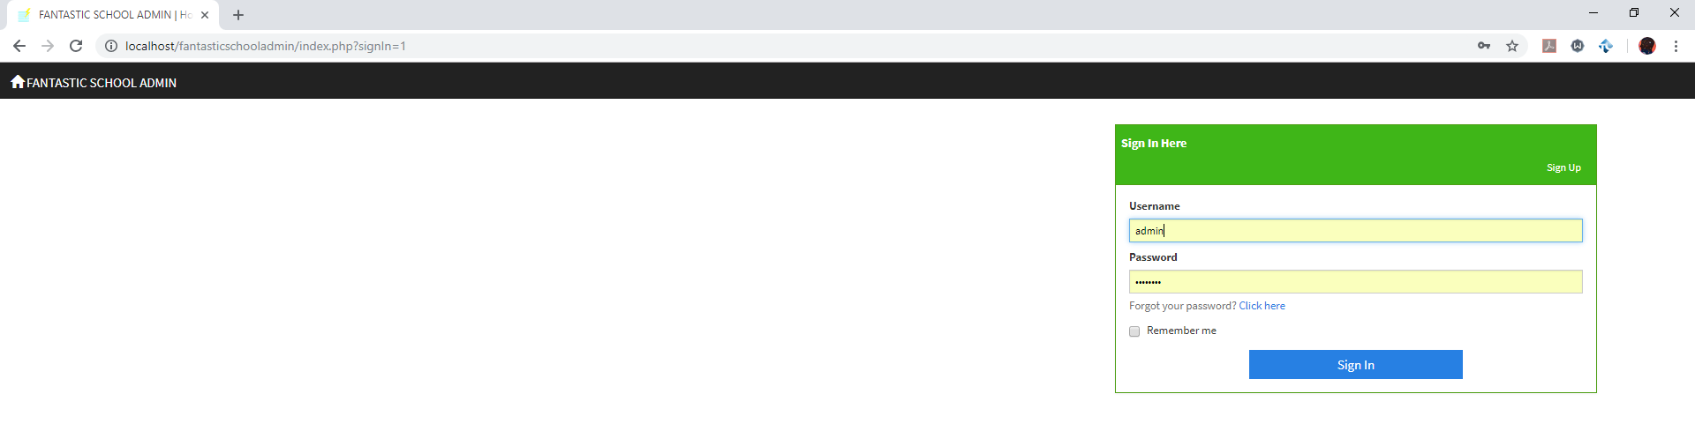
Figure 53: Login page as shown above.
- Navigate through the system through clicking the buttons of the user interface or through the jump to button in each page visited as follows: -
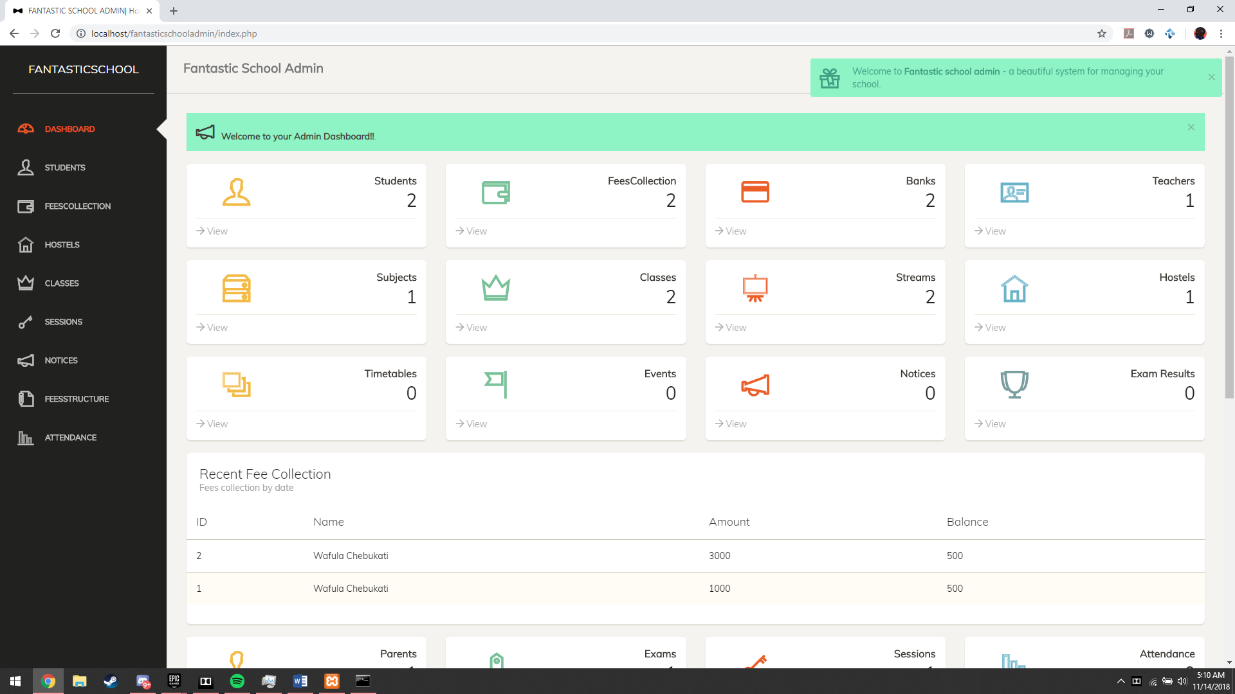
Figure 54: Navigation of each page through home page using navigation bar or name of pages in main area as shown above.
This only applies to the homepage.
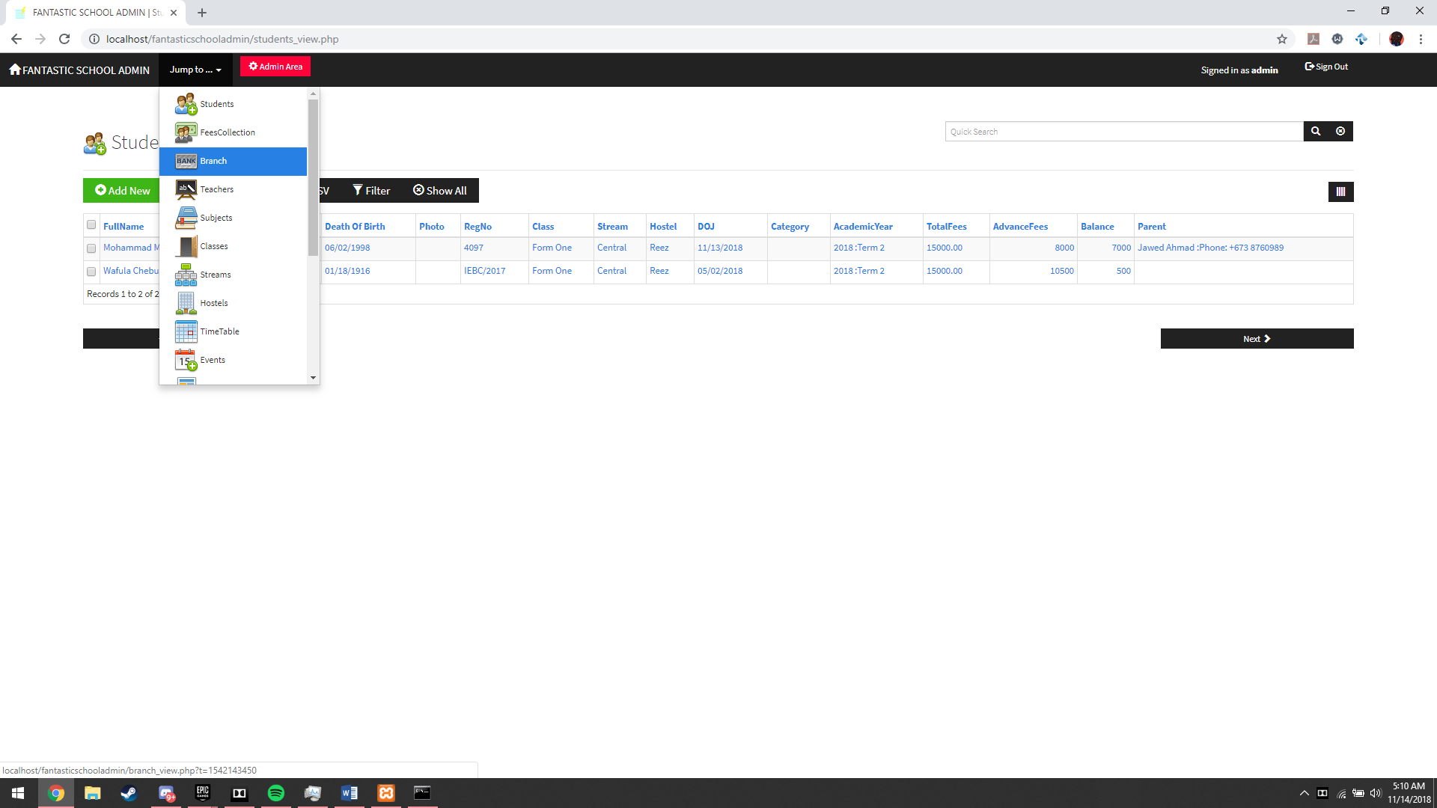
Figure 55: Jump to button for navigation in a visited page as shown above.
This applies to any sub-page of the website and allows us to jump to any other page the user wishes to go to.
- Adding a record to a selected page or table: -
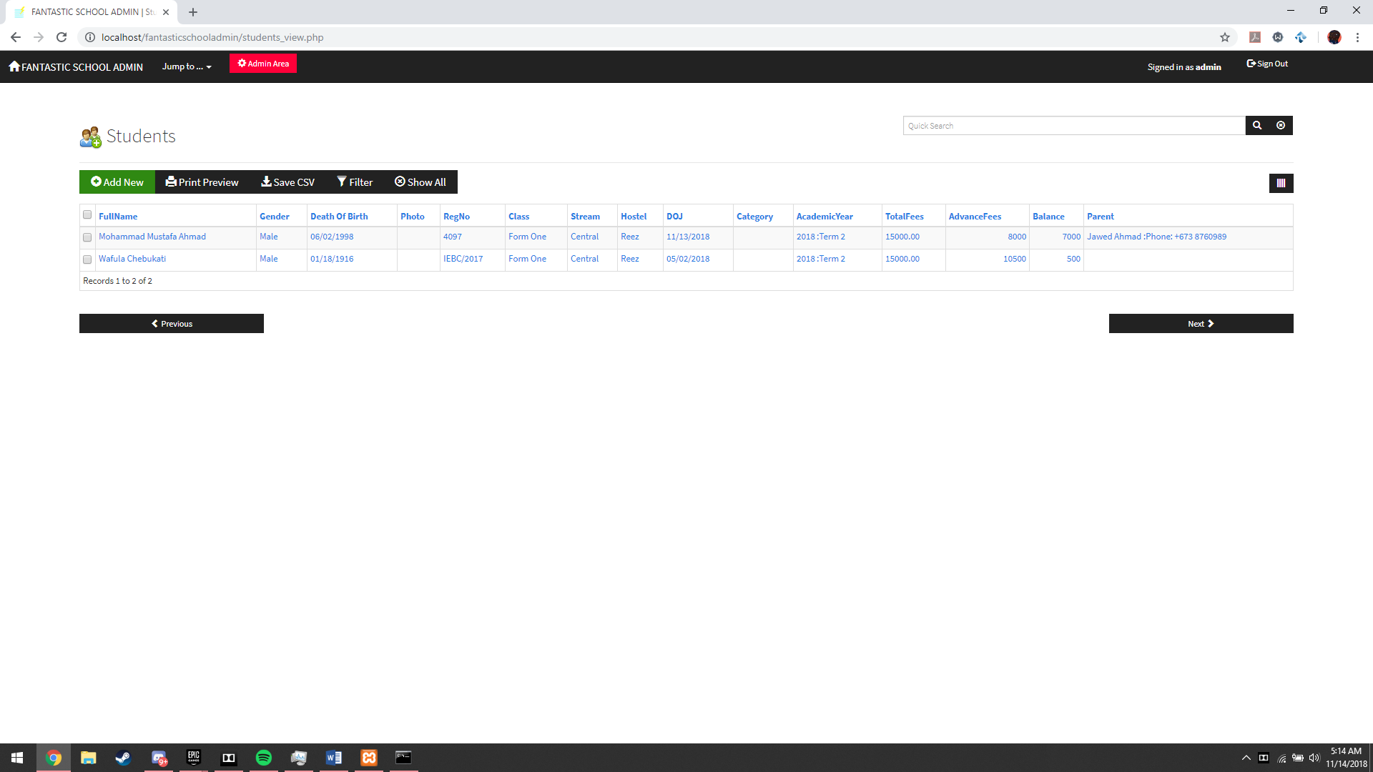
Figure 56: Add new button for the students table as shown above.
This allows us to add a new record in any table we wish to as this button is universal.
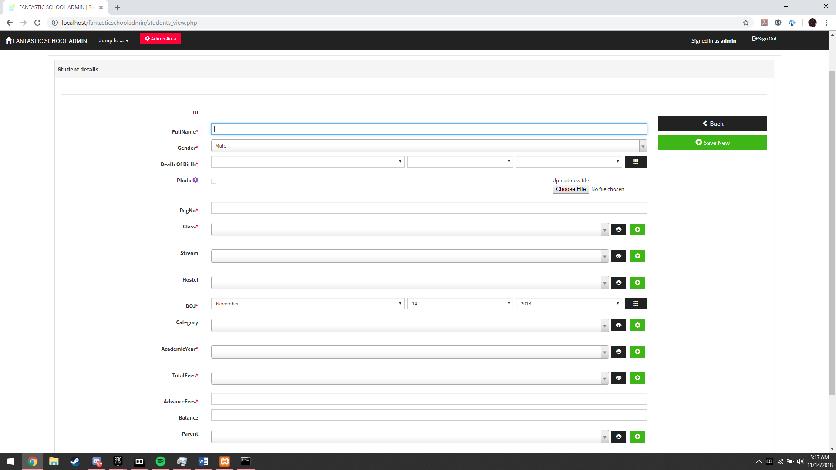
Figure 57: Add form for a record, in this case student as shown above.
A form for necessary fields is to be filled depending on which page and what record is to be used for the student. Simply click +save new and the record is added.
- Printing preview of records and printing records
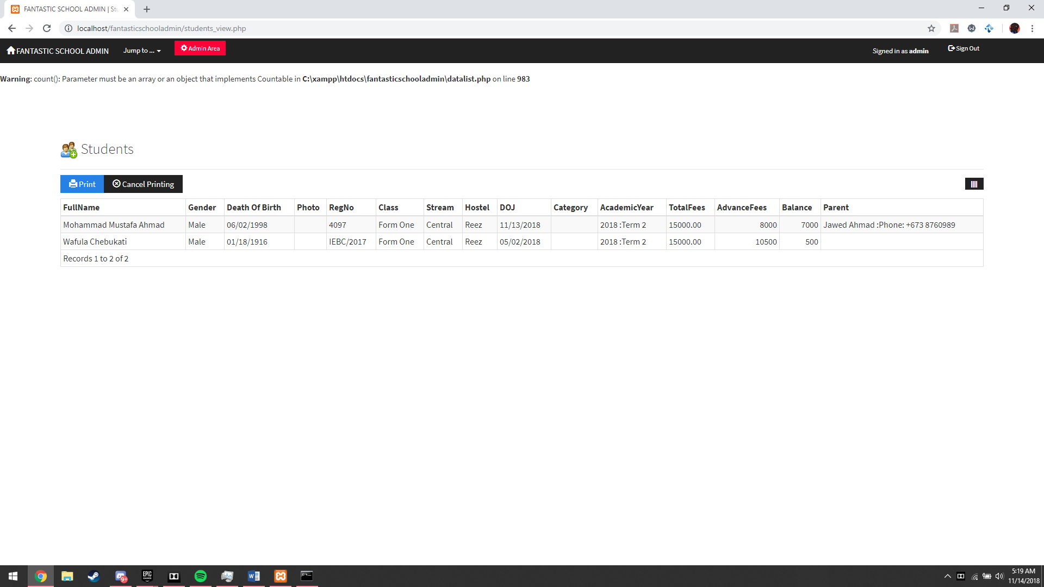
Figure 58: Print preview of the student table as shown above.

Simply click printing preview and then you can choose to print by clicking print and the following prompt comes out :
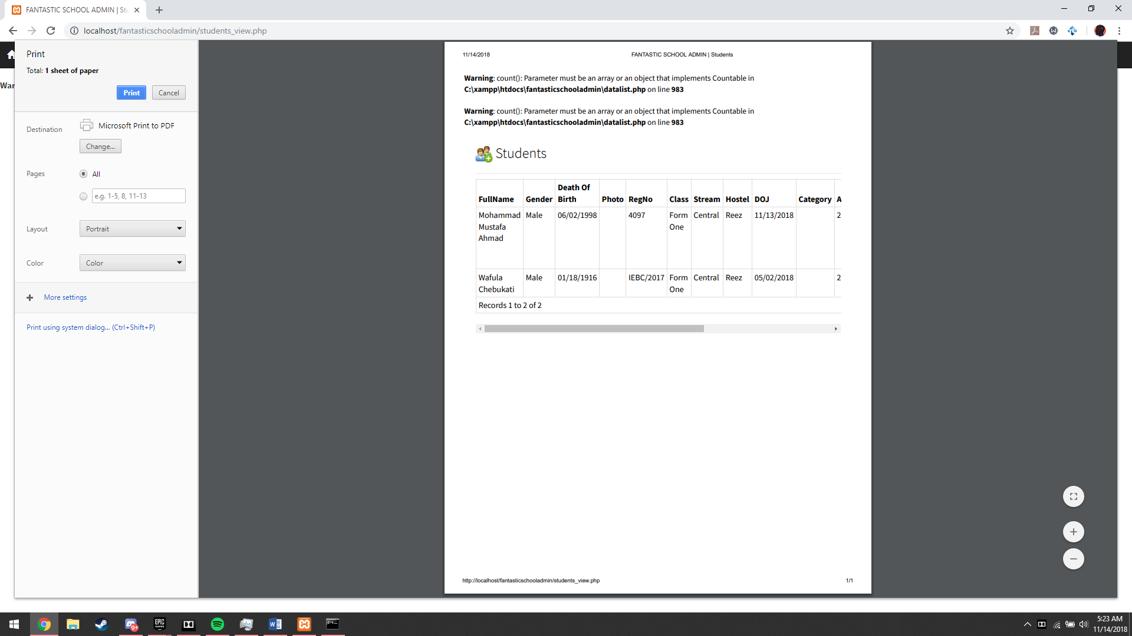
Figure 59: Print options as shown above.
Here we can print and the page beside shows how the page will print out.
- Saving records as CSV files (Microsoft Excel)
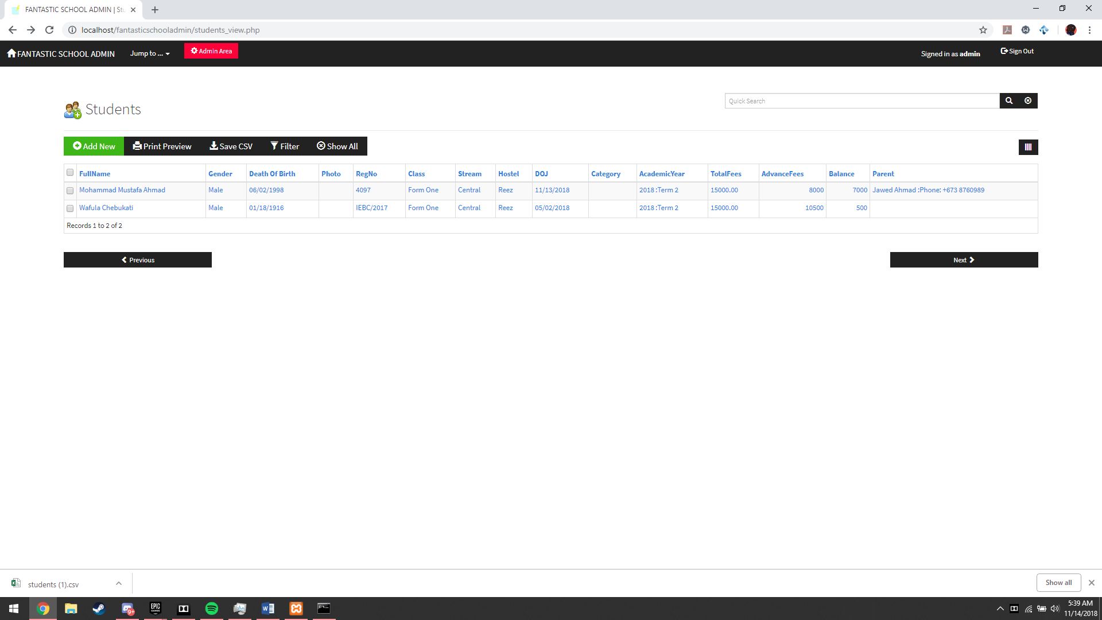
Figure 60: Save CSV file and CSV file download in Google Chrome as shown above.
This allows us to export the record and view it in Microsoft Excel as shown : -
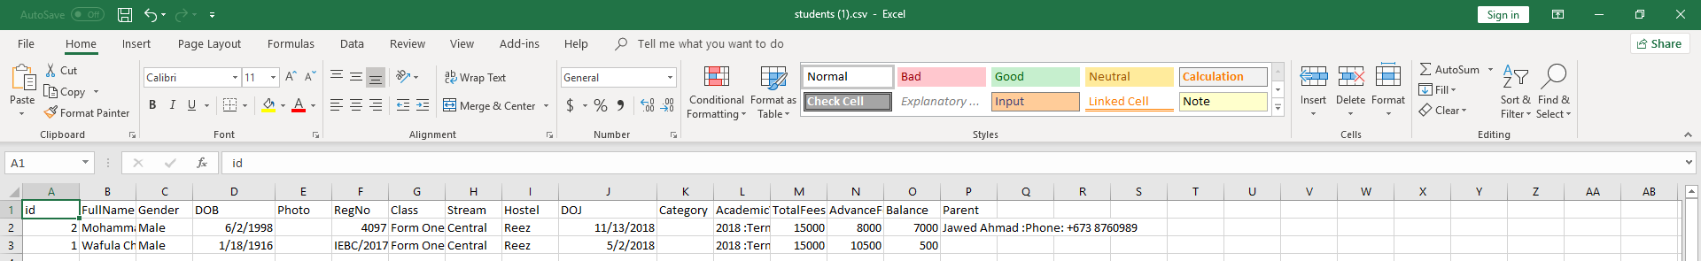
Figure 61: Microsoft Excel displaying students table records as shown above.
- Admins area for viewing newest update, entries and top members of the admin group and also adding groups and new admin members.
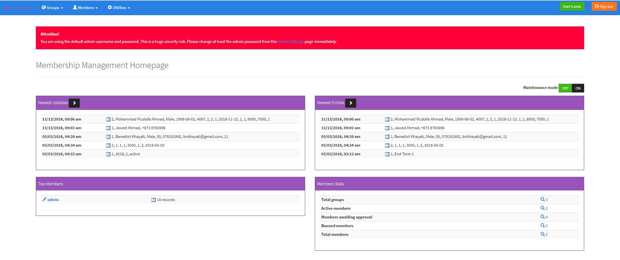
Figure 62: Admin's Area page as shown above.

Users can add new groups of administrators depending on the administrator privilege, view them and edit their permissions as such: -
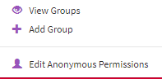
Figure 63: Group settings for admin's area as shown above.
Users can view members of the administrators, add them and also view members’ records as such: -
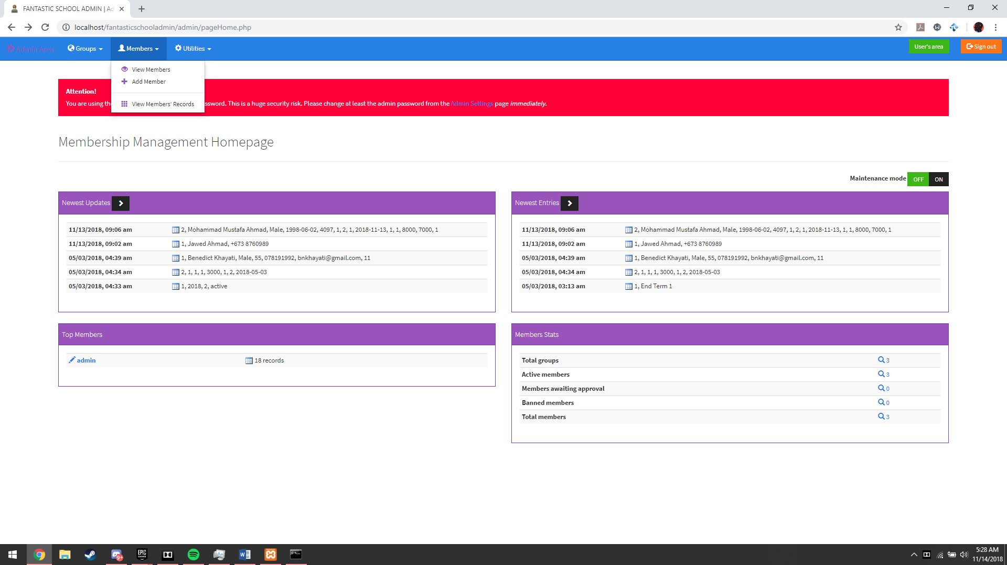
Figure 64: Member settings for admin's page as shown above.
Admin utilities are also available: -
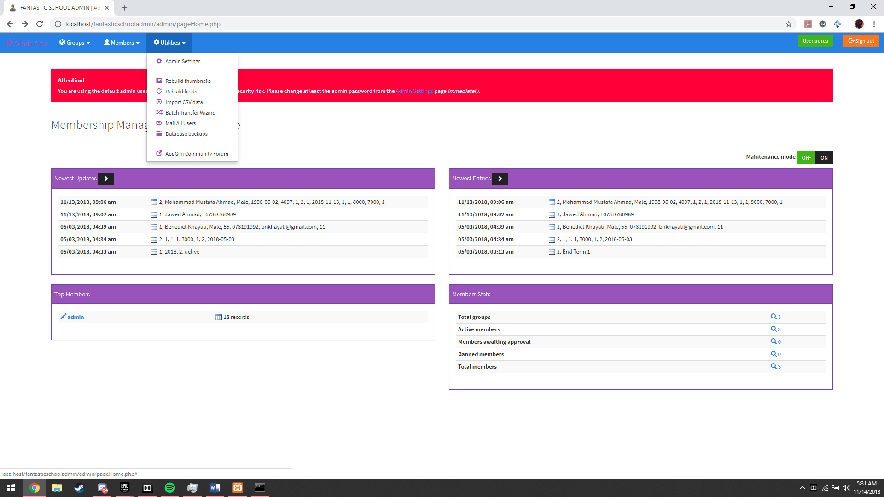
Figure 65: Admin utilities for admin's page as shown above.
Rebuilding thumbnails allow the database to rebuild thumbnails of photos in the case that thumbnails are broken or unavailable. Rebuilds fields does the same thing in order to properly organize the tables. Import CSV data allows us to export some fields or records into a Microsoft Excel file. Batch transfer wizard allows us to batch transfer several records from various tables into a CSV file that is used by Microsoft Excel. Mail All users mail the users of the admin site according to what is to be e-mailed set by the mailer. Database backups allow the user to backup the database to their liking and vacate it to another machine in the event of a natural disaster or even an off-site server.

- Last but not least, signing out is available for any page as shown in the students table page: -
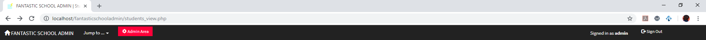
Figure 66: Sign out option as shown above.
The user may simply click log out by clicking the sign out button as shown above.

References
Apache Tomcat®. (2018, n.d. n.d.). Apache Tomcat® - Welcome! Retrieved from Apache Tomcat®: n.d.
Chris. (2012, June 27). How to use Mercury Mail in XAMPP. Retrieved from New Coder's Life: https://newcoderslife.wordpress.com/2012/06/27/how-to-use-xampps-mail-server-mercury-mail/
Eftaiha, D. (2012, July 12). An Introduction to Apache. Retrieved from Tuts+: https://code.tutsplus.com/tutorials/an-introduction-to-apache--net-25786
MySQL. (2018, n.d. n.d.). 1.3.1 What is MySQL? Retrieved from MySQL™: https://dev.mysql.com/doc/refman/8.0/en/what-is-mysql.html
Upjohn, C. (2011, October n.d.). XAMPP FileZilla: How to use? Retrieved from SitePoint: https://www.sitepoint.com/community/t/xampp-filezilla-how-to-use/8247

