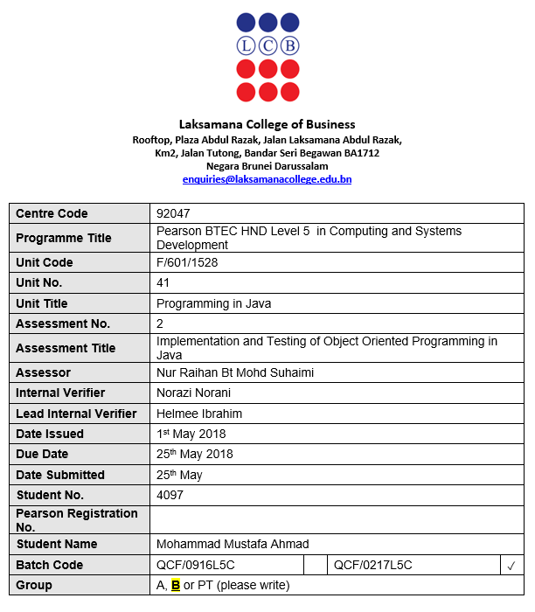

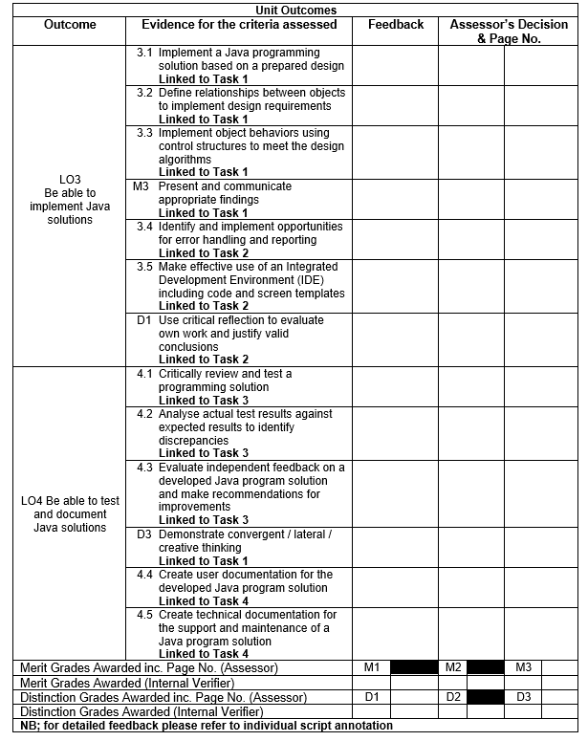
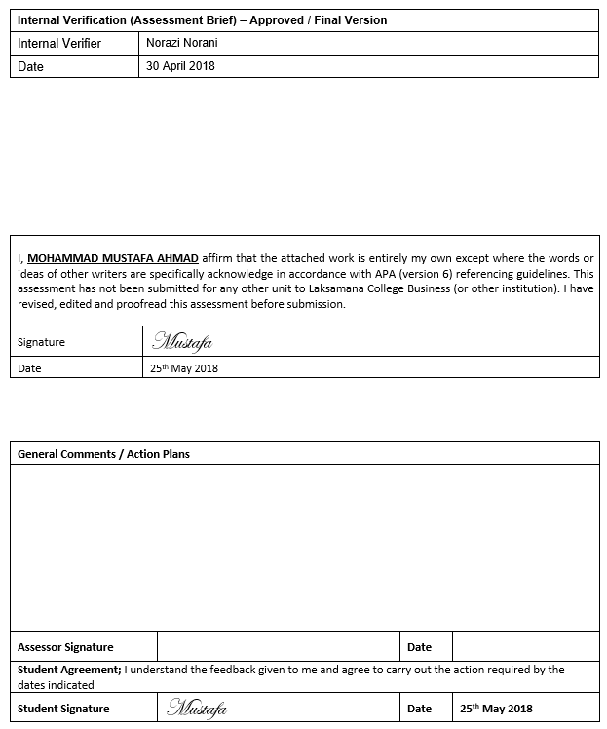

Table of Contents
List of Figures 5
List of tables 7
Task 1 – Implement Java solutions 8
Task 1.1 – Implementation of object-oriented solution using Java 8
Task 1.2 – Relationships between classes, instance variables and methods 14
Task 1.3 – 2 functions in the design system 17
Task M3 (Merit 3) – Control structures 19
Task D3 (Distinction 3) – Implementation of a GUI to demonstrate creative thinking 20
Task 2 – Further implementation of Java solutions 26
Task 2.1 – Error handling and reporting techniques 26
Task 2.2 – Use of IDE and its built-in functionality 27
28
Task D1 (Distinction 1) – Critical evaluation of the selected IDE 29
Task 3 – Test & Document Java solutions 29
Task 3.1 – Test cases & Test plan 29
Task 3.2 – Report of test results against expected results 30
Task 3.3 – Questionnaire for independent user feedback 31
Task 4 – Further Test & Document Java solutions 33
Task 4.1 – User manual 33
Task 4.2 – Technical manual 40
Appendices 42
References 46

List of Figures
Figure 1: First 49 lines of the source code in IntelliJ as shown above. 8
Figure 2: The next 48 lines of source code in IntelliJ as shown above. 9
Figure 3: The next 48 lines of source code in IntelliJ as shown above. 10
Figure 4: The next 48 lines of source code in IntelliJ as shown above. 11
Figure 5: The next 48 lines of source code in IntelliJ as shown above. 12
Figure 6: The last 42 lines of source code in IntelliJ as shown above. 13
Figure 7: Payment option output with no interface as shown above. 13
Figure 8: Lines 7-19 showing instantiated variables in IntelliJ as shown above. 14
Figure 9: Relationship between instantiated variables within the Payment sub-module or class as shown above. 15
Figure 10: Function or method "Balance" in IntelliJ as shown above. 15
Figure 11: "Balance" function being called into payment calculation in IntelliJ as shown above. 15
Figure 12: Java Swing being imported in IntelliJ for use in the program as shown above. 16
Figure 13: Java Option Pane being brought up as a function from Java Swing in order to print out the welcome screen for the user interface as shown above. 16
Figure 14: User interface for welcome screen using Java Swing and Java Option Pane as shown above. 16
Figure 15: "displayMessage()" function source code in IntelliJ as shown above. 17
Figure 16: Function "displayMessage()" being called in order to print a message as shown above. 17
Figure 17: Displayed message after function being called as shown in the red highlighted box as shown above. 17
Figure 18: Function "Balance" which calculates the amount to be paid by the customer as shown above. 18
Figure 19: Function "Balance" being called in order to calculate the amount to be paid by the customer as shown above. 18
Figure 20: Calculated payment or amount to be paid after the user has input the necessary integer values. 18
Figure 21: An example of if control structures highlighted in red as shown above. 19
Figure 22: Welcome screen interface as shown above. 20
Figure 23: Login option pane for the customer or staff. 20
Figure 24: Username entry for staff as shown above. 20
Figure 25: Welcoming the staff member into the interface as shown above. 20
Figure 26: Password entry for staff as shown above. 21
Figure 27: Successful login of staff member as shown above. 21
Figure 28: Register Customer or Exit interface as shown above. 21
Figure 29: Assigning the Customer ID in the interface as shown above. 22
Figure 30: Entering the customer's full name in the interface as shown above. 22
Figure 31: Entering the customer's home address in the interface as shown above. 22
Figure 32: Entering the customer's phone number in the interface as shown above. 22
Figure 33: Entering the customer's date of birth in the interface as shown above. 22
Figure 34: Display Information or Exit choice in the interface as shown above. 23
Figure 35: Displayed information after registering a customer as shown above. 23
Figure 36: Membership selection in the interface as shown above. 23
Figure 37: Standard or VIP Membership selection for new registered customer as shown above. 24
Figure 38: Customer username entry in the interface as shown above. 24
Figure 39: Welcoming the customer to the login interface after entering their username as shown above. 24
Figure 40: Password entry in the interface as shown above. 25
Figure 41: Prompting the user that they have successfully log in as shown above. 25
Figure 42: Standard or VIP Membership Type selection in the interface as shown above. 25
Figure 43: Throwing and catching exceptions made in Standard membership in the source code as shown above. 26
Figure 44: Throwing and catching exceptions made in VIP membership in the source code as shown above. 26
Figure 45: Syntax suggestions from IntelliJ as shown above. 27
Figure 46: Debug information from IntelliJ as shown above. 27
Figure 47: Java swing and input mismatch exception import as shown above. 28
Figure 48: Java swing and input mismatch exception being used in the source code as shown above. 28
Figure 49: 1st Questionnaire feedback form as shown above. 31
Figure 50: 2nd Questionnaire feedback form as shown above. 32
Figure 51: Run button highlighted red in IntelliJ as shown above. 33
Figure 52: Welcome interface as shown above. 33
Figure 53: Staff or Customer option in the interface as shown above. 33
Figure 54: Enter staff username as shown above. 34
Figure 55: Welcoming staff member for login as shown above. 34
Figure 56: Enter staff password as shown above. 34
Figure 57: Welcoming the staff member after a successful login. 34
Figure 58: Entering the Customer ID as shown above. 35
Figure 59: Entering the customer full name as shown above. 35
Figure 60: Entering the customer address as shown above. 35
Figure 61: Entering the customer phone number as shown above. 35
Figure 62: Entering the customer Date of Birth as shown above. 35
Figure 63: Display information or exit option in the interface as shown above. 36
Figure 64: Displayed information of the last registered customer as shown above. 36
Figure 65: Standard or VIP Membership type interface as shown above. 36
Figure 66: Result of scenario given as shown above. 37
Figure 67: Entering the Customer ID as shown above. 37
Figure 68: Entering the customer full name as shown above. 37
Figure 69: Entering the customer address as shown above. 38
Figure 70: Entering the customer phone number as shown above. 38
Figure 71: Entering the customer Date of Birth as shown above. 38
Figure 72: Membership selection for the new customer. 38
Figure 73: Customer username entry in the interface as shown above. 39
Figure 74: Welcoming the customer to the login interface after entering their username as shown above. 39
Figure 75: Password entry in the interface as shown above. 39
Figure 76: Prompting the user that they have successfully log in as shown above. 39
Figure 77: Standard or VIP Membership Type selection in the interface as shown above. 39
Figure 78: Instantiated variables as shown above. 40
Figure 79: Throw and catch exception handling as shown above. 40
Figure 80: Imported functions as shown above. 41
Figure 81: 2 functions made as shown above. 41

List of tables
Table 1: List of test cases and the plans in order to carry them out. 28
Table 2: List of expected result compared to actual result and seeing if the program has passed or failed. 29

Task 1 – Implement Java solutions

Task 1.1 – Implementation of object-oriented solution using Java
The selected object-oriented solution was made upon the request of True Fitness Sdn Bhd in order to create a gym management system, the selected IDE is IntelliJ Community using a Java Development Kit (JDK). Below are screenshots of the source code for the implemented solution:
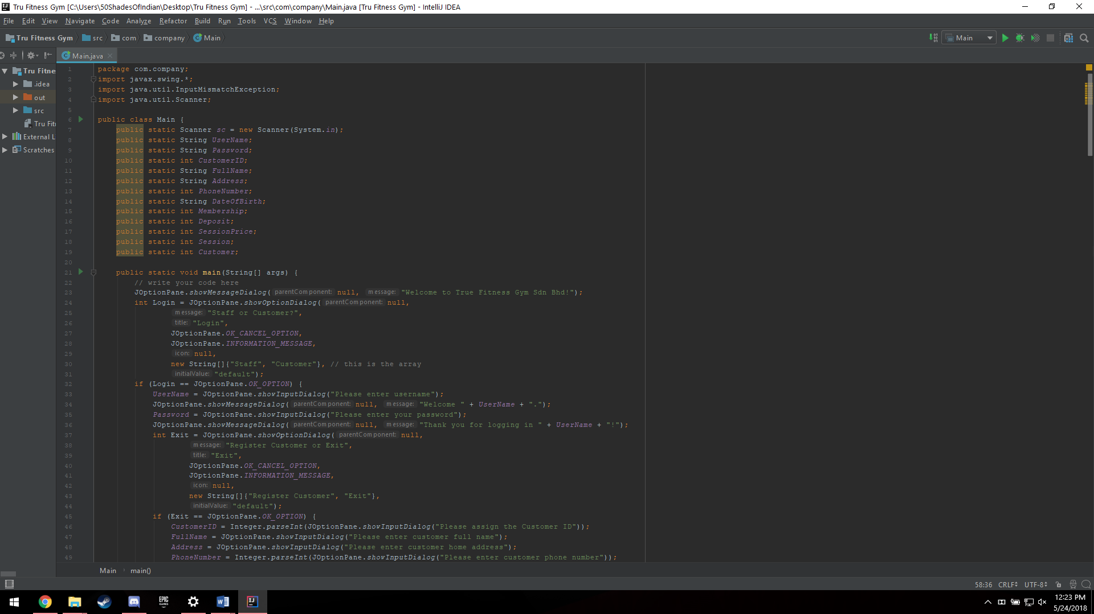
Figure 1: First 49 lines of the source code in IntelliJ as shown above.

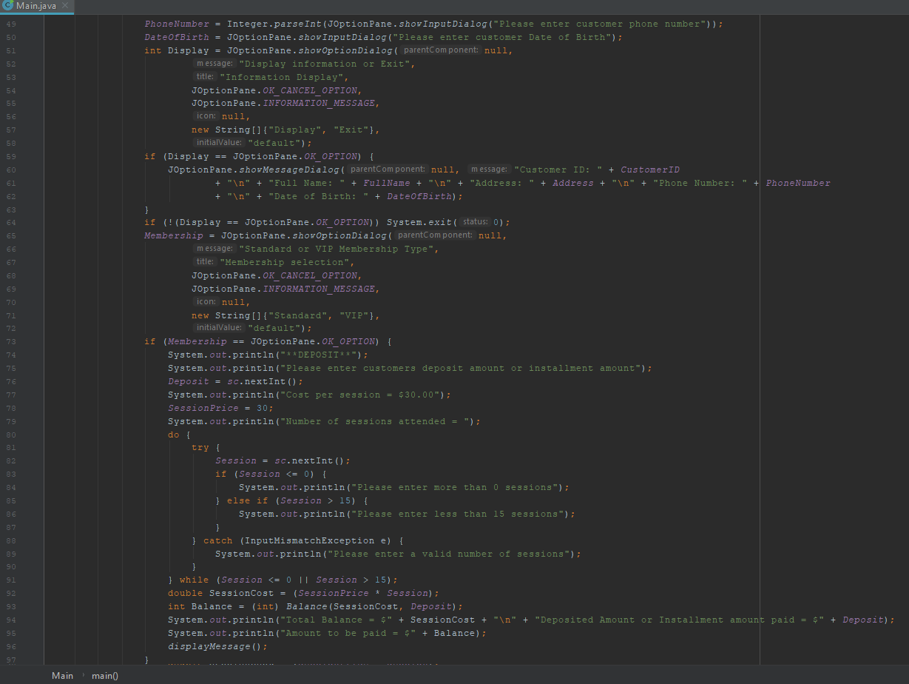
Figure 2: The next 48 lines of source code in IntelliJ as shown above.
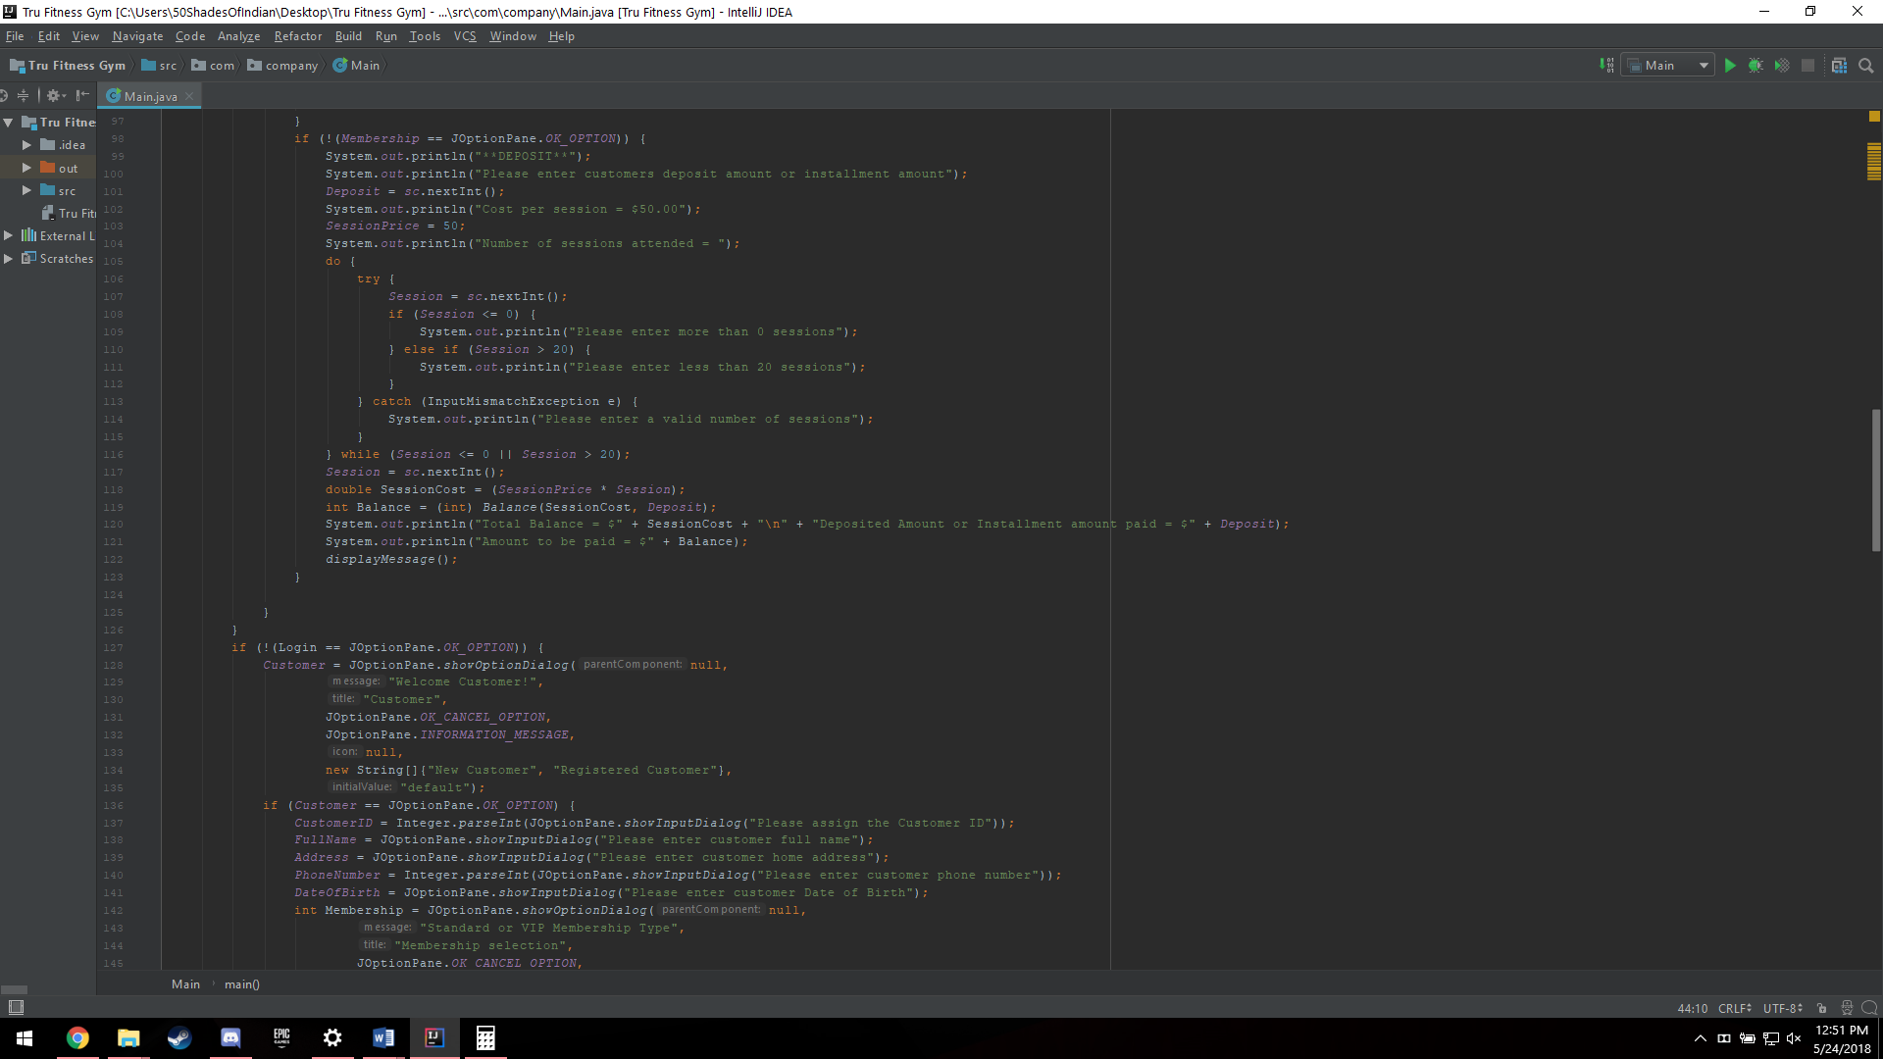
Figure 3: The next 48 lines of source code in IntelliJ as shown above.

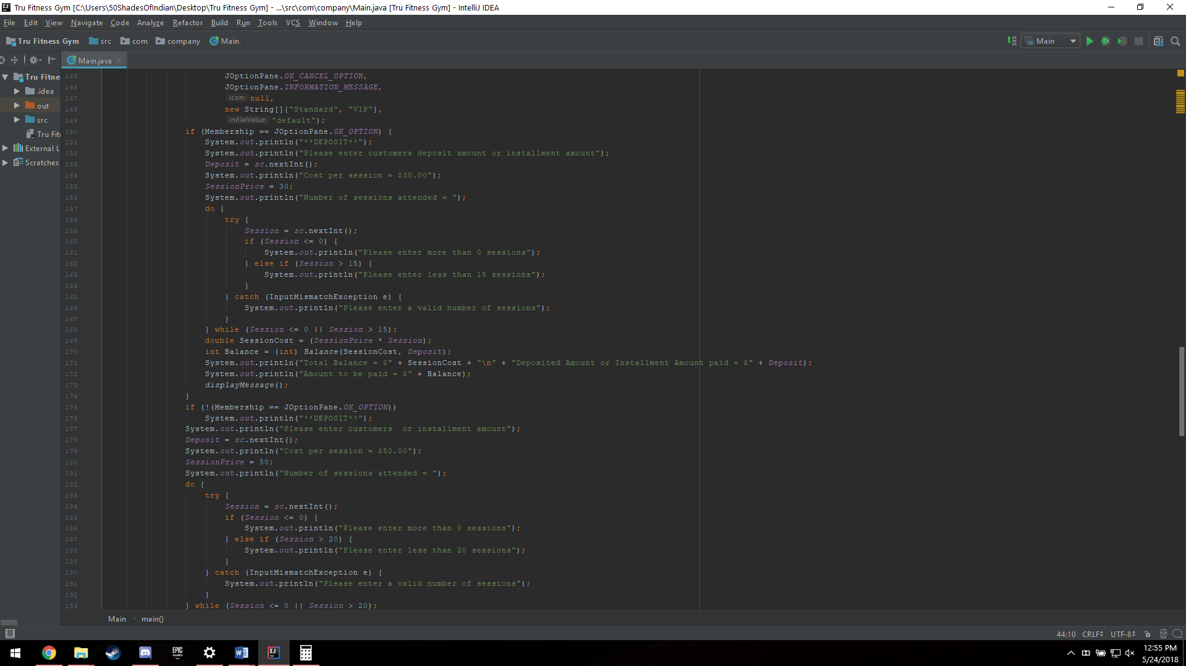
Figure 4: The next 48 lines of source code in IntelliJ as shown above.

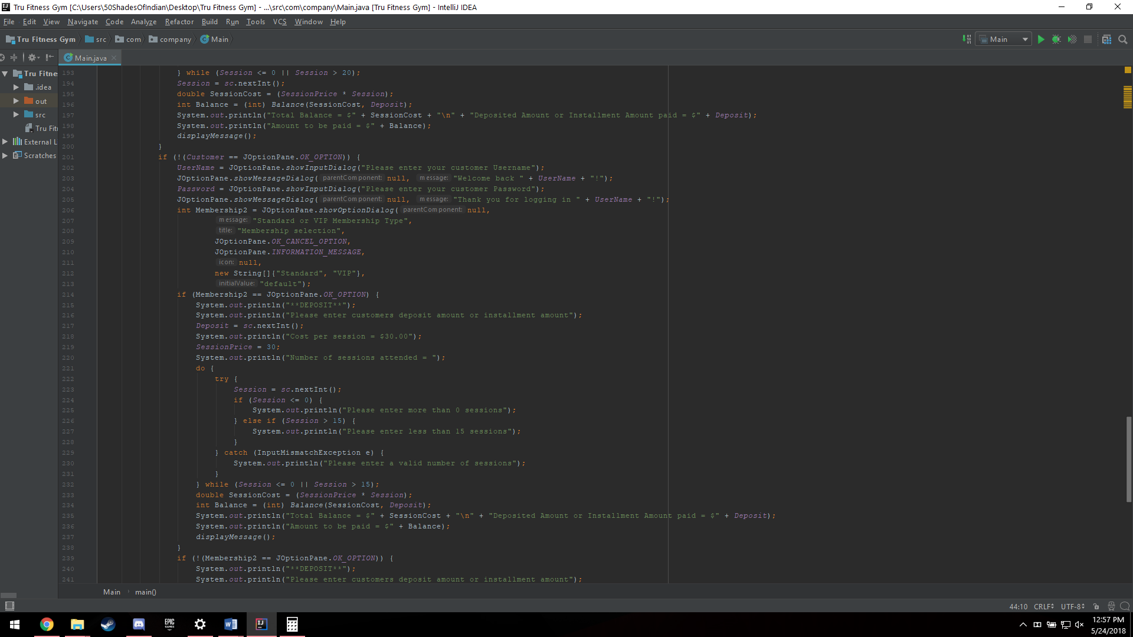
Figure 5: The next 48 lines of source code in IntelliJ as shown above.

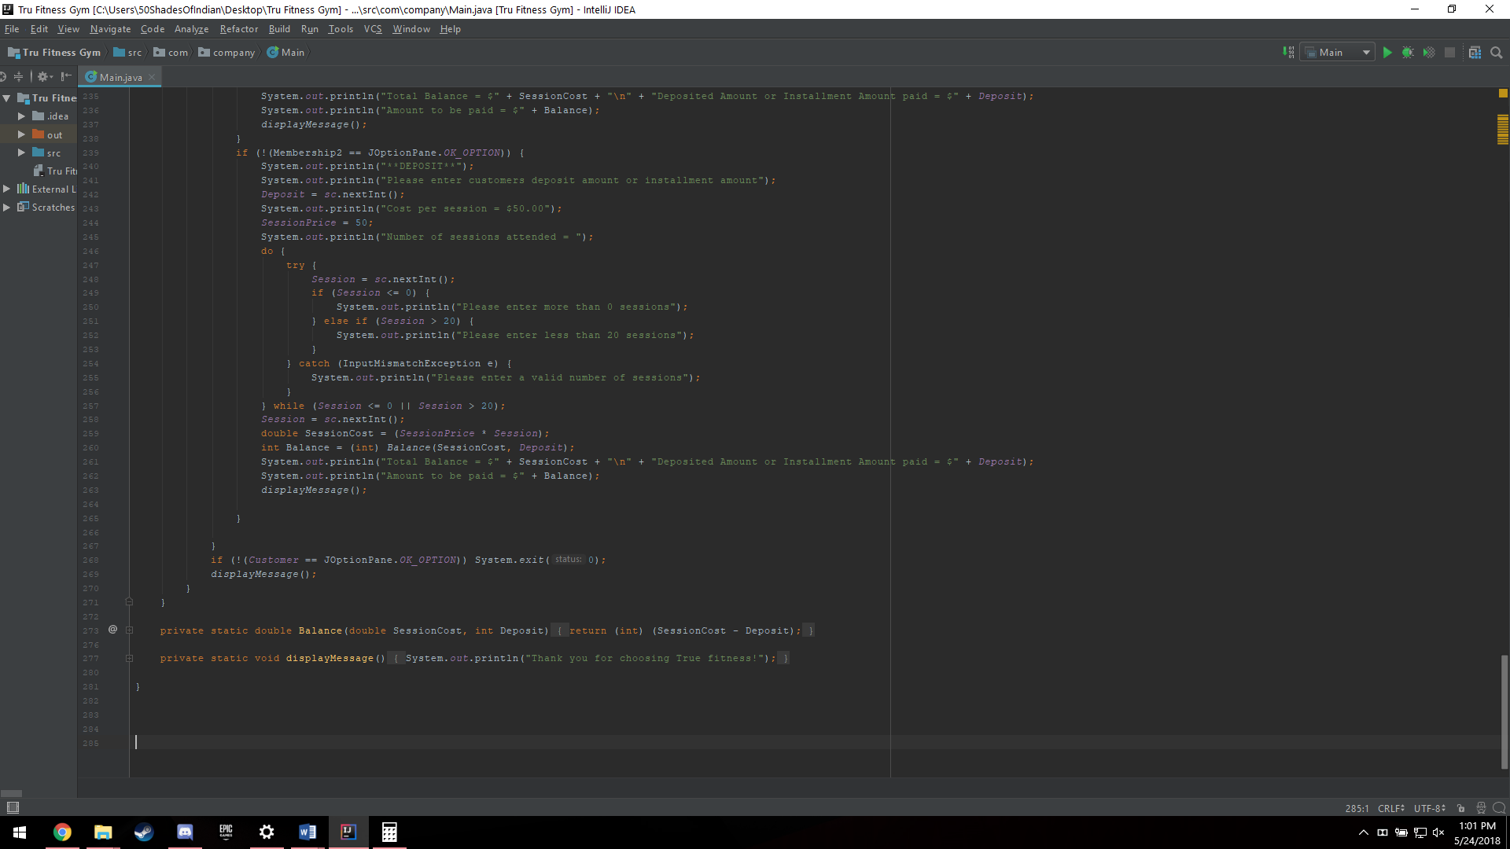
Figure 6: The last 42 lines of source code in IntelliJ as shown above.
Here is the payment option output:
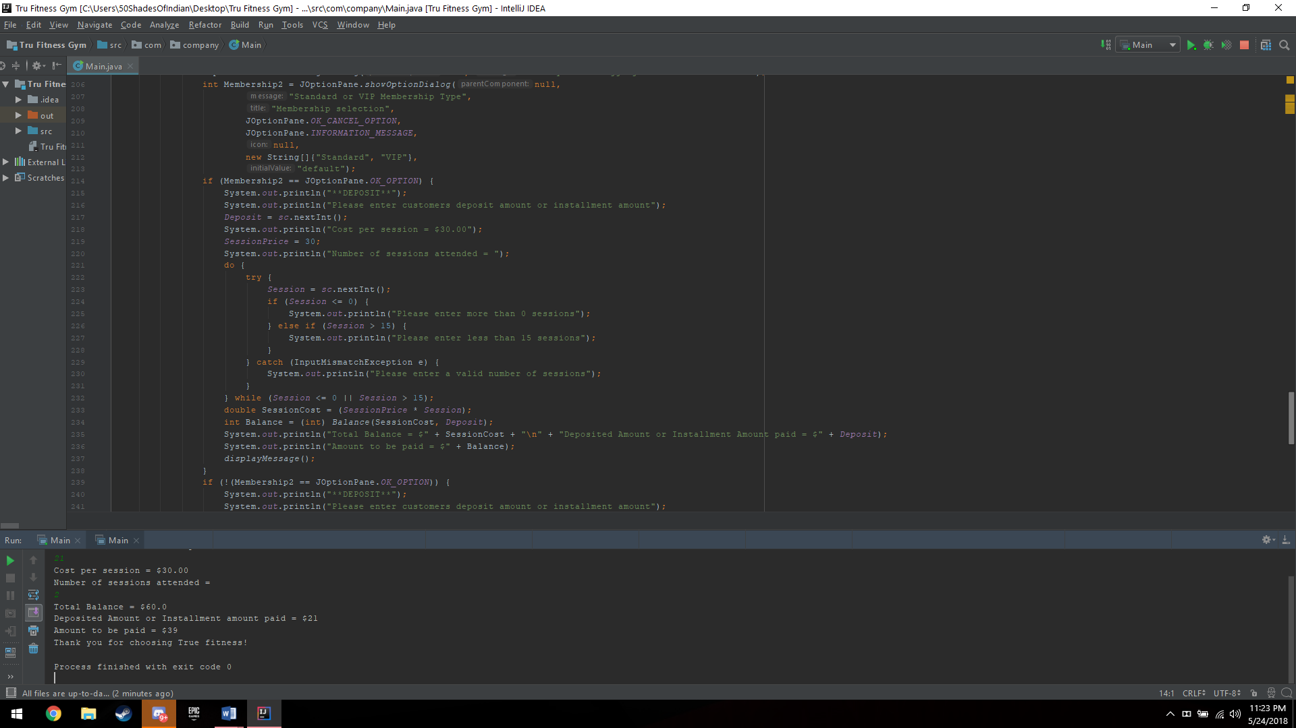
Figure 7: Payment option output with no interface as shown above.
As you can see, from the source code, the payment option is used several times, basically the exact same code for different areas, so the result is the same, an output of the cost per session, along with the number of sessions attended, the total balance, deposited or installment amount and then the remaining amount to be paid followed by an exit message.

Task 1.2 – Relationships between classes, instance variables and methods
Since there is only class in this, the relationships are limited to instance variables and methods only, here we can see that in lines 7-19 we have instantiated variables in the forms of only strings and integers:
Figure 8: Lines 7-19 showing instantiated variables in IntelliJ as shown above.
The “UserName” and “Password” strings are used for individual logins for customers and staff members. “CustomerID” as an integer to create a unique ID for each individual customer for easy lookup in future use or development of the program once a database has been implemented. String items such as “FullName, Address, DateOfBirth,” are used for customers and registration for new customers. The integer “PhoneNumber” is also used in the same scenario but only numbers are allowed. “Membership” was used as an integer to allow Java Option Panes to give the customer a choice of their membership type based on the panel they choose, that being either “Standard” or “VIP”. Other integers such as “Deposit, SessionPrice, Session” are strictly used for payment sub-module in order to calculate the balance of the customer to show what amount they have pay. “Customer” integer is used to identify whether the customer is new or not for the Java Option Panes. Instead of using string for Customer and Membership, we reduce coding redundancies of repeated variables that may get mixed up as they are repeatedly used for different cases.

These instantiated variables have a relationship in the Java program such as being dependent on other values, for example, in the Payment sub-class we can see that the terms “Deposit, SessionPrice, Session and Customer” are all instantiated variables with attached values that the user must input in order to calculate their total balance to show much outstanding payments they have. Below is the code showing this:
Figure 9: Relationship between instantiated variables within the Payment sub-module or class as shown above.
Here we can see that the code for the instantiated variables including “Membership is being called out in order to instantiate and label certain values in order to make the program run smoothly.
For the relationships of the methods, we have only one method that has been repeatedly called in order to help with the payment function, this function is referred to as “Balance”. And in order to call out the function, we simply type out “int Balance() = int Balance(SessionCost -Deposit ” this function helps us calculate the final balance for the customer. Below is the code of the function and an instance in which it is called upon:
Figure 10: Function or method "Balance" in IntelliJ as shown above.
And here is when it is called:
Figure 11: "Balance" function being called into payment calculation in IntelliJ as shown above.
We also have built in functions which are repeatedly called out, making it related to the entire GUI such as the Java Swing GUI utility which allows us to create option panes in order for the user to have an interface to react with, it has been used repeatedly over the course of nearly the entire program except for payment sub-class. Here is the code for the above mention:
Figure 12: Java Swing being imported in IntelliJ for use in the program as shown above.
And here is the Java Swing built in functions being utilized:
Figure 13: Java Option Pane being brought up as a function from Java Swing in order to print out the welcome screen for the user interface as shown above.
And the outcome of this interface would look as such:
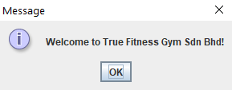
Figure 14: User interface for welcome screen using Java Swing and Java Option Pane as shown above.

Task 1.3 – 2 functions in the design system
Only two functions were utilized in this program, one being a function to print out a message upon exiting the program after registering a customer or paying as an already registered member under different memberships. The other function being utilized for payment sub-module in the program. Here is the first function:
Figure 15: "displayMessage()" function source code in IntelliJ as shown above.
As you can see, this function has been utilized to print an exit message for the user. To call out this function, simply type “displayMessage()” and the message “Thank you for choosing True fitness!” shall be displayed. And here is an example of that function being called out along with its result:
Figure 16: Function "displayMessage()" being called in order to print a message as shown above.
And this being the printed message:
Figure 17: Displayed message after function being called as shown in the red highlighted box as shown above.
As you can see from the highlighted box that is in red, we get a message output saying, “Thank you for choosing True fitness!”.

The second function requires some parameter passing, in which an instantiated variable or variables are called into the function, then used to make a formula in order to alter values and come up with an intended result. Which in this case, we calculate the total balance or amount to be paid by the customer. Below is the source code of the function:
Figure 18: Function "Balance" which calculates the amount to be paid by the customer as shown above.
The function is instantiated within the class “Main” and is a double as it can store multiple values at a value. The variables “SessionCost” and “Deposit” are then called, which must be in integers which is the parameter passing and returned only after the “SessionCost” and “Deposit” variables are subtracted from each other. Here is where the function is called and its result:
Figure 19: Function "Balance" being called in order to calculate the amount to be paid by the customer as shown above.
And here is the result of the function:
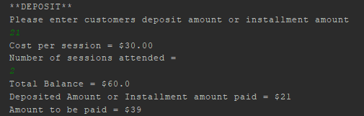
Figure 20: Calculated payment or amount to be paid after the user has input the necessary integer values.

Task M3 (Merit 3) – Control structures
The control structures implemented in this program was mostly if and else statements. These statements were mostly used in regard to whether the user has chosen a certain option from the Java Option Dialog in order to move to another certain interface depending on their previous choice. Here is a screenshot of the following control structure:
Figure 21: An example of if control structures highlighted in red as shown above.
As mentioned earlier, the if control structure is used IF the user has made a previous choice in order to navigate through the system and IF the user must enter a certain type of data value in the program.

Task D3 (Distinction 3) – Implementation of a GUI to demonstrate creative thinking
The Java Swing built in function was imported in order to create option panes in order for the user to have a proper user interface. The user interface is as shown:
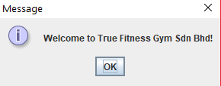
Figure 22: Welcome screen interface as shown above.
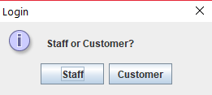
Figure 23: Login option pane for the customer or staff.
Upon selecting staff, the user is prompted to enter their username and password, which are as follows:
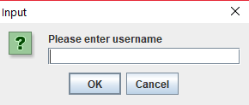
Figure 24: Username entry for staff as shown above.
After which they are welcomed:
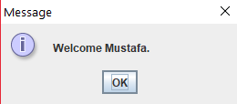
Figure 25: Welcoming the staff member into the interface as shown above.

After which the staff is prompted to enter a password:
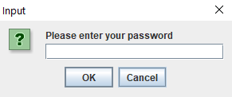
Figure 26: Password entry for staff as shown above.
And then the staff member is thanked for successfully logging in:
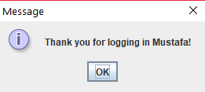
Figure 27: Successful login of staff member as shown above.
From here, another interface comes out asking whether or not to register a customer or exit:
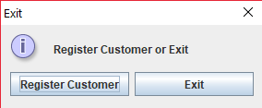
Figure 28: Register Customer or Exit interface as shown above.
If the user chooses register customer, the user is presented with another interface but if exit was chosen, the program executes a system exit command. Here is an instance if the user has chosen to register a customer, they are presented with entering the Customer ID which can only be in integers:
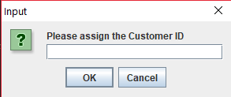
Figure 29: Assigning the Customer ID in the interface as shown above.
After which, the full name of the customer must be entered:
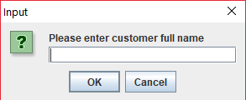
Figure 30: Entering the customer's full name in the interface as shown above.
Which is followed by entering the customer home address:
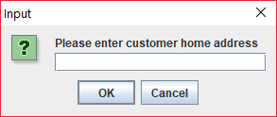
Figure 31: Entering the customer's home address in the interface as shown above.
Followed by the entry of the customer’s phone number which is only in integers, meaning only numbers allowed:
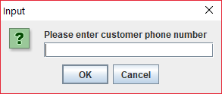
Figure 32: Entering the customer's phone number in the interface as shown above.
Then lastly, the date of birth of the customer be entered to complete the registration:
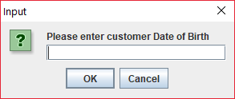
Figure 33: Entering the customer's date of birth in the interface as shown above.

After all details have been entered, the staff member is met with the choice of displaying the information that was previously entered to ensure that the customer has the correct details and to avoid any mistyped characters or letters:
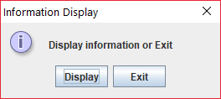
Figure 34: Display Information or Exit choice in the interface as shown above.
If the staff member chooses to display the information, another interface comes out showing the customer information then exiting the program, or if the staff member chooses to exit directly then they may choose to do so. Here is an instance where the staff has chosen to display information:
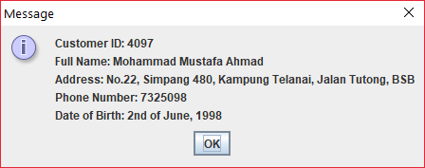
Figure 35: Displayed information after registering a customer as shown above.
After clicking “OK”, the option of registering the customer under a standard or VIP membership is shown:
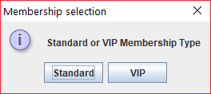
Figure 36: Membership selection in the interface as shown above.
From here, no user interface is given but rather a display of messages within IntelliJ is given and for that, we are not going to show this as this task explicitly asks for a GUI based screenshot only.

Now here is an instance where in Figure 21, the user has chosen the customer option, an interface giving an option of New Customer or Registered Customer is shown:
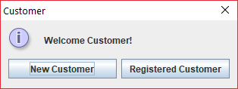
Now if the user chooses New Customer they are prompted to fill in details similar to that of registering a customer in the Staff area. Which you can refer to as the process steps shown in Figures 27 through 31. After which the customer has a choice of becoming a Standard or VIP member as shown:
And from here, as stated previously we are not going to include what follows next as it does not use a GUI (Graphical User Interface).
Figure 37: Standard or VIP Membership selection for new registered customer as shown above.
In the case of choosing Registered Customer, the user is prompted to login with their Customer Username and Password as shown:
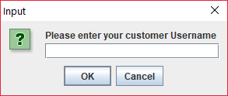
Figure 38: Customer username entry in the interface as shown above.
After which they welcome the customer user to the interface:
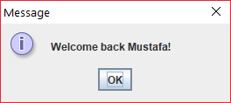
Figure 39: Welcoming the customer to the login interface after entering their username as shown above.
From there, the customer is then prompted to enter their password:
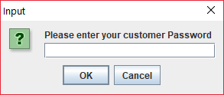
Figure 40: Password entry in the interface as shown above.
After which the user has been prompted with a successful login:
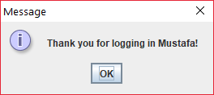
Figure 41: Prompting the user that they have successfully log in as shown above.
Then the user must choose under which membership they are in:
Figure 42: Standard or VIP Membership Type selection in the interface as shown above.
And again, as previously stated, we are presented with the payment sub-module which will not be shown here as it does not utilize Java Swing and is not represented with a Graphical User Interface (GUI).

Task 2 – Further implementation of Java solutions

Task 2.1 – Error handling and reporting techniques

Figure 43: Throwing and catching exceptions made in Standard membership in the source code as shown above.
The throw and catch exception handling has been made for when the user has to enter the amount of sessions they enter. For Standard sessions, the user must enter a value above 0 and equal to or below 15. If the user doesn’t do so, such as less than or equal to 0, the message “Please enter more than 0 sessions” comes out. If the user enters more than 15 sessions, the message “Please enter less than 15 sessions”. And lastly, if the user enters a non-integer value, the message “Please enter a valid number of sessions”. All of this is ongoing only if the session numbers are only less than or equals to 0 and above 15.
Now in the case that the user is a VIP membership, the following throw and catch exception handling is used:

Figure 44: Throwing and catching exceptions made in VIP membership in the source code as shown above.
Same concept for the Standard membership, but this time the number of sessions limit is above 0 and equals to or below 20. So, in the case that it is below or equals to 0, the message “Please enter more than 0 sessions” is displayed. In another case where the user enters more than 20 sessions, the message “Please enter less than 20 sessions” is displayed. And also, if the user enters a non-integer value, the message “Please enter a valid number of sessions”. All of this is done while the session numbers are only less than or equals to 0 and above 20.

Task 2.2 – Use of IDE and its built-in functionality
(All information and research made in this section of the assignment is referenced to (Computer Weekly, 2012))
One of the very distinct features of the selected IDE which is IntelliJ is that it has template code and in which if the user types out code that exists in the programming language chosen which in this case is Java, the IDE is smart enough to give simple syntax suggestions or shortcuts for long texts of code such as the following:
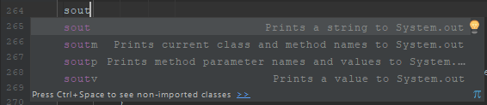
Figure 45: Syntax suggestions from IntelliJ as shown above.
Another feature is the debugging area in which if a syntax does not match its value or there is a missing brace in the beginning or ending of a code, the program is smart enough to identify the missing brace and tells the user that a brace is expected which can be seen below:
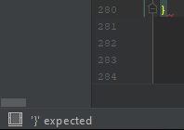
Figure 46: Debug information from IntelliJ as shown above.
As you can see from the figure above, if a brace is missing at the of a code, the user is notified at the bottom left of the program window and that a “}” or brace is expected to be there.

Another few built in functionalities is the use of importing functions in a programming language, which again in this case is Java, we have imported two functions, which are Java Swing and Java Mismatch Exception. Java Swing was utilized to create a graphical user and that Java Mismatch Exception is used for throw and catch exception handling in the source code. Below is a screenshot of the Java Swing and Java Input Mismatch Exception import and it’s use:
Figure 47: Java swing and input mismatch exception import as shown above.
Which is then followed by its use:

Figure 48: Java swing and input mismatch exception being used in the source code as shown above.
The area that is highlighted in red is the Java Swing function and the area highlighted in yellow is the area that utilizes the input mismatch exception.
There are a lot of functionalities within the selected IDE but of the most relatable and most used are the ones that have been mentioned in the above task.

Task D1 (Distinction 1) – Critical evaluation of the selected IDE
IntelliJ is a very versatile and well-made Integrated Development Environment (IDE). It supports many languages that even the operating system of the user does not support, and it comes both in a free version and paid version. The paid version being that you can compile and create usable programs for web development and mobile devices. It supports object-oriented programming which is very important, because without that it means that we could not have utilized it for this assignment. IntelliJ is very easy to pick up and use, simply download the program and install, and from there make sure you have the necessary files in order to run the programming environment in which you have chosen in order to run the program on your IDE. Another good thing about IntelliJ is that it comes with templates for the code and forms of the programs, this means that it adapts to any program language that it supports and informs the user of any syntax errors or discrepancies. It also allows you to compile your program once you are done and create a testing environment in order to check if your program has worked as expected. Lastly, being able to export the files into a compressed folder format such as a ZIP file in order for easy sharing and to save data storage.

Task 3 – Test & Document Java solutions

Task 3.1 – Test cases & Test plan
The following is a trace table of only what the test case is and the plan to execute it, in the following task is the expected results against the
Test Case | Addressed Task | Expected Result
Staff Login | Staff member must try to login to the program in order to register a new customer | Successful login of the staff member
Customer Login | Customer must login after being registered as a new customer or as an already registered customer | Customer must be able to login as a new customer after registering or as an already registered customer
Display Customer Information | Display customer information after the staff has entered their details upon registering a customer | Customer information should be displayed on a window pane
Payment as a Standard member | Calculate payment for a customer based on the fact that they are a Standard Member | Payment should be calculated properly and number of sessions limited to 15
Payment as a VIP member | Calculate payment for a customer based on the fact that they are a VIP Member | Payment should be calculated properly and number of sessions limited to 20
Table 1: List of test cases and the plans in order to carry them out.

Task 3.2 – Report of test results against expected results
The following is what happens after the test has been taken and the expected results against actual results.
Expected Result | Actual Result | Pass or Fail
Successful login of the staff member | Login was successful for the staff member | Pass
Customer must be able to login as a new customer after registering or as an already registered customer | Customer was able to login after registration and an already registered customer was able to login successfully as well. | Pass
Customer information should be displayed on a window pane | Customer information was displayed completely after being registered by a staff member | Pass
Payment should be calculated properly and number of sessions limited to 15 | Payment was calculated and if the user entered any value between 1 and 15, the session number was accepted | Pass
Payment should be calculated properly and number of sessions limited to 20 | Payment was calculated and if the user entered any value between 1 and 20, the session number was accepted | Pass
Table 2: List of expected result compared to actual result and seeing if the program has passed or failed.
As you can see from the table above, expected results are compared with the actual results carried out by the program in order to evaluate whether the program has passed or failed in this area.

Task 3.3 – Questionnaire for independent user feedback
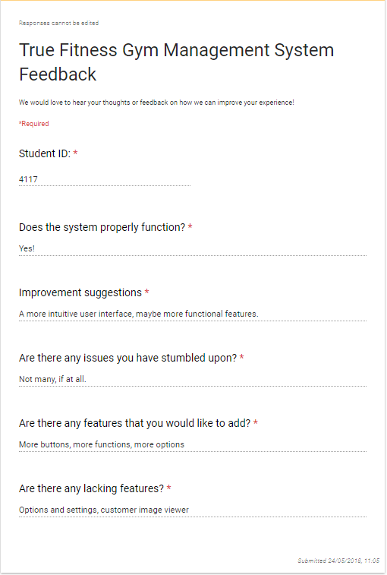
Figure 49: 1st Questionnaire feedback form as shown above.

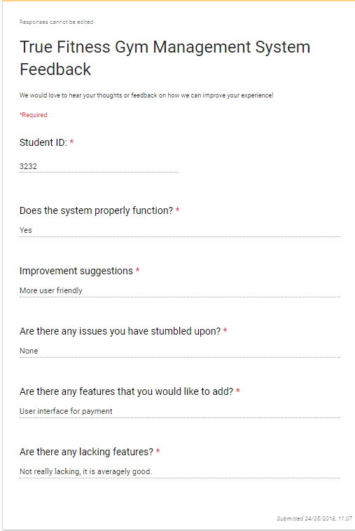
Figure 50: 2nd Questionnaire feedback form as shown above.

From both feedback forms we can see that the users have not stumbled into any problems with the program, the only features it lacks is that there should be some options and settings, along with a customer image viewer. Another improvement suggestion is to create a much better user interface that is user friendly as the user interface implemented is very plain. The users have also agreed that the program is fully functional.

Task 4 – Further Test & Document Java solutions

Task 4.1 – User manual
For users to be able to use the program, a number of steps and procedures in order to properly navigate and avoid errors in the system.
For staff:
For staff members kindly refer to this part, as staff members can register new customers and then choose their payment option under the specified membership. Here are the procedures:
First of all, open the program in IntelliJ, and when the user is presented with a long list of coding, simply ignore it and click on the run button on the top right corner:
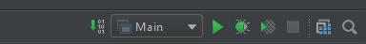
Figure 51: Run button highlighted red in IntelliJ as shown above.
The button highlighted is the button to be pressed.
From here, the program welcomes the user:
Figure 52: Welcome interface as shown above.
Click okay, and then click on Staff in the next interface as shown:
Figure 53: Staff or Customer option in the interface as shown above.

After which the staff member must input their username which will be followed by a welcome and then enter their password which is then followed by a successful login welcome interface:
Figure 54: Enter staff username as shown above.
Figure 55: Welcoming staff member for login as shown above.
Figure 56: Enter staff password as shown above.

Figure 57: Welcoming the staff member after a successful login.

Now the staff member is introduced with another interface in which they must choose whether they would like to register a customer or exit, choosing to register a customer will bring up another interface that allows them to register a customer which is as follows:
Figure 58: Entering the Customer ID as shown above.
Figure 59: Entering the customer full name as shown above.
Figure 60: Entering the customer address as shown above.
Figure 61: Entering the customer phone number as shown above.
Figure 62: Entering the customer Date of Birth as shown above.
These are all the customer details the staff member must enter in order for the customer to be properly registered under the gym. Note that Customer ID and Phone Number accept only numbers. So please bear in mind that integers or digits are to be only used in this area.
From here the staff member may choose to display the entered information once or more or exit the program, if they choose to display the information an interface as such is shown:
Figure 63: Display information or exit option in the interface as shown above.
Figure 64: Displayed information of the last registered customer as shown above.
Here we can see information of the last registered customer after which the staff member is prompted to choose whether the member is under a Standard or VIP membership:
Figure 65: Standard or VIP Membership type interface as shown above.

Now all the staff member has to do is ask the customer what package they would like and ask for the number of sessions they wish to attend along with the amount of which they are going to deposit, so let’s say for instance the user is under a standard membership and chose 10 sessions and deposits $100, we get this result from the in-line command app:
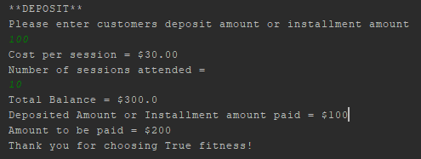
Figure 66: Result of scenario given as shown above.
From there, the program exits and that is all the staff member has to do.
For Customers:
Now for customers to use the program, start off with what staff members have to do and that is to run the program off IntelliJ but this time after the welcome screen shown in figure 52, select “Customer”.
The customer will be given two choices, which is New Customer or Registered Customer and depending on what the customer has chosen a set of interfaces will come out, in the case that the customer is new, the following steps happen:
Figure 67: Entering the Customer ID as shown above.
Figure 68: Entering the customer full name as shown above.
Figure 69: Entering the customer address as shown above.
Figure 70: Entering the customer phone number as shown above.
Figure 71: Entering the customer Date of Birth as shown above.
All of these are fields the new customer must enter, same as registering their information under a staff account, keep in mind that Customer ID and Phone Number accept integers or digits only!
After this, the customer is met with the choice of proceeding as a Standard membership or VIP, and then accustomed to the payment feature afterwards as shown here:
Figure 72: Membership selection for the new customer.
After selecting the membership type, again the user must fill out a payment section in which they enter the number of sessions attended and the amount they wish to pay. Just as shown in figure 65.

Now for already registered customers, they will be shown a screen in which they must enter their username and password as shown:
Figure 73: Customer username entry in the interface as shown above.
Figure 74: Welcoming the customer to the login interface after entering their username as shown above.
Figure 75: Password entry in the interface as shown above.
Figure 76: Prompting the user that they have successfully log in as shown above.
Figure 77: Standard or VIP Membership Type selection in the interface as shown above.
Then again, they are prompted to enter their payment amount and their sessions attended during the month which was shown in figure 65.

Task 4.2 – Technical manual
Here is a manual for future programmers or developers to be able to understand the thought process in the programming.
First of all, the instantiated variables of the program:
Figure 78: Instantiated variables as shown above.
The instantiated variables refer to the classes or variables used in the source code in order to identify values or to be used in functions. Future programmers or developers can rename these variables to they’re liking.
Another thing to keep in mind with the technical manual is the throw and catch exception handling in which the user must be able to enter a certain type of data value for an entry as such:

Figure 79: Throw and catch exception handling as shown above.
The future programmer or developer may choose to add this type of error or exception handling for the username, password, phone number and customer ID in which the user is only allowed to enter the specified username and password to properly login. And the Phone Number must contain at least 7 digits and that the customer ID is to be unique from any other ID’s along with it being only an integer or digit.
The program runs on if and else or purely if statements in which customer interaction dictates what happens next depending on the if controls implemented.

Lastly, functions are to be added in the future or to be maintained such as the Java Swing, Java System Scanner and Java Input Mismatch exception which are all utilized in this source in order to be able to create more graphical user interface, scan selected user inputs and to filter the inputs strictly based on what type of data input is required or needed by the program for other instantiated variables. Here are the functions imported:
Figure 80: Imported functions as shown above.
There are also functions that were made to show parameter passing and printing message, the code is as follows:
Figure 81: 2 functions made as shown above.
One function being a double in order to store multiple high values in order to carry out a formulated function which calculates the amount to be paid left by the customer. And another in which it prints out the message “Thank you for choosing True fitness!” wherever this function is being called within the program. From here, the developer or programmer should understand what the program is doing and what can be edited or added on later in future uses for this gym management system.

Appendices
package com.company;
import javax.swing.*;
import java.util.InputMismatchException;
import java.util.Scanner;
public class Main {
public static Scanner sc = new Scanner(System.in);
public static String UserName;
public static String Password;
public static int CustomerID;
public static String FullName;
public static String Address;
public static int PhoneNumber;
public static String DateOfBirth;
public static int Membership;
public static int Deposit;
public static int SessionPrice;
public static int Session;
public static int Customer;
public static void main(String[] args) {
// write your code here
JOptionPane.showMessageDialog(null, "Welcome to True Fitness Gym Sdn Bhd!");
int Login = JOptionPane.showOptionDialog(null,
"Staff or Customer?",
"Login",
JOptionPane.OK_CANCEL_OPTION,
JOptionPane.INFORMATION_MESSAGE,
null,
new String[]{"Staff", "Customer"}, // this is the array
"default");
if (Login == JOptionPane.OK_OPTION) {
UserName = JOptionPane.showInputDialog("Please enter username");
JOptionPane.showMessageDialog(null, "Welcome " + UserName + ".");
Password = JOptionPane.showInputDialog("Please enter your password");
JOptionPane.showMessageDialog(null, "Thank you for logging in " + UserName + "!");
int Exit = JOptionPane.showOptionDialog(null,
"Register Customer or Exit",
"Exit",
JOptionPane.OK_CANCEL_OPTION,
JOptionPane.INFORMATION_MESSAGE,
null,
new String[]{"Register Customer", "Exit"},
"default");
if (Exit == JOptionPane.OK_OPTION) {
CustomerID = Integer.parseInt(JOptionPane.showInputDialog("Please assign the Customer ID"));
FullName = JOptionPane.showInputDialog("Please enter customer full name");
Address = JOptionPane.showInputDialog("Please enter customer home address");
PhoneNumber = Integer.parseInt(JOptionPane.showInputDialog("Please enter customer phone number"));
DateOfBirth = JOptionPane.showInputDialog("Please enter customer Date of Birth");
int Display = JOptionPane.showOptionDialog(null,
"Display information or Exit",
"Information Display",
JOptionPane.OK_CANCEL_OPTION,
JOptionPane.INFORMATION_MESSAGE,
null,
new String[]{"Display", "Exit"},
"default");
if (Display == JOptionPane.OK_OPTION) {
JOptionPane.showMessageDialog(null, "Customer ID: " + CustomerID
+ "\n" + "Full Name: " + FullName + "\n" + "Address: " + Address + "\n" + "Phone Number: " + PhoneNumber
+ "\n" + "Date of Birth: " + DateOfBirth);
}
if (!(Display == JOptionPane.OK_OPTION)) System.exit(0);
Membership = JOptionPane.showOptionDialog(null,
"Standard or VIP Membership Type",
"Membership selection",
JOptionPane.OK_CANCEL_OPTION,
JOptionPane.INFORMATION_MESSAGE,
null,
new String[]{"Standard", "VIP"},
"default");
if (Membership == JOptionPane.OK_OPTION) {
System.out.println("**DEPOSIT**");
System.out.println("Please enter customers deposit amount or installment amount");
Deposit = sc.nextInt();
System.out.println("Cost per session = $30.00");
SessionPrice = 30;
System.out.println("Number of sessions attended = ");
do {
try {
Session = sc.nextInt();
if (Session <= 0) {
System.out.println("Please enter more than 0 sessions");
} else if (Session > 15) {
System.out.println("Please enter less than 15 sessions");
}
} catch (InputMismatchException e) {
System.out.println("Please enter a valid number of sessions");
}
} while (Session <= 0 || Session > 15);
double SessionCost = (SessionPrice * Session);
int Balance = (int) Balance(SessionCost, Deposit);
System.out.println("Total Balance = $" + SessionCost + "\n" + "Deposited Amount or Installment amount paid = $" + Deposit);
System.out.println("Amount to be paid = $" + Balance);
displayMessage();
}
if (!(Membership == JOptionPane.OK_OPTION)) {
System.out.println("**DEPOSIT**");
System.out.println("Please enter customers deposit amount or installment amount");
Deposit = sc.nextInt();
System.out.println("Cost per session = $50.00");
SessionPrice = 50;
System.out.println("Number of sessions attended = ");
do {
try {
Session = sc.nextInt();
if (Session <= 0) {
System.out.println("Please enter more than 0 sessions");
} else if (Session > 20) {
System.out.println("Please enter less than 20 sessions");
}
} catch (InputMismatchException e) {
System.out.println("Please enter a valid number of sessions");
}
} while (Session <= 0 || Session > 20);
Session = sc.nextInt();
double SessionCost = (SessionPrice * Session);
int Balance = (int) Balance(SessionCost, Deposit);
System.out.println("Total Balance = $" + SessionCost + "\n" + "Deposited Amount or Installment amount paid = $" + Deposit);
System.out.println("Amount to be paid = $" + Balance);
displayMessage();
}
}
}
if (!(Login == JOptionPane.OK_OPTION)) {
Customer = JOptionPane.showOptionDialog(null,
"Welcome Customer!",
"Customer",
JOptionPane.OK_CANCEL_OPTION,
JOptionPane.INFORMATION_MESSAGE,
null,
new String[]{"New Customer", "Registered Customer"},
"default");
if (Customer == JOptionPane.OK_OPTION) {
CustomerID = Integer.parseInt(JOptionPane.showInputDialog("Please assign the Customer ID"));
FullName = JOptionPane.showInputDialog("Please enter customer full name");
Address = JOptionPane.showInputDialog("Please enter customer home address");
PhoneNumber = Integer.parseInt(JOptionPane.showInputDialog("Please enter customer phone number"));
DateOfBirth = JOptionPane.showInputDialog("Please enter customer Date of Birth");
int Membership = JOptionPane.showOptionDialog(null,
"Standard or VIP Membership Type",
"Membership selection",
JOptionPane.OK_CANCEL_OPTION,
JOptionPane.INFORMATION_MESSAGE,
null,
new String[]{"Standard", "VIP"},
"default");
if (Membership == JOptionPane.OK_OPTION) {
System.out.println("**DEPOSIT**");
System.out.println("Please enter customers deposit amount or installment amount");
Deposit = sc.nextInt();
System.out.println("Cost per session = $30.00");
SessionPrice = 30;
System.out.println("Number of sessions attended = ");
do {
try {
Session = sc.nextInt();
if (Session <= 0) {
System.out.println("Please enter more than 0 sessions");
} else if (Session > 15) {
System.out.println("Please enter less than 15 sessions");
}
} catch (InputMismatchException e) {
System.out.println("Please enter a valid number of sessions");
}
} while (Session <= 0 || Session > 15);
double SessionCost = (SessionPrice * Session);
int Balance = (int) Balance(SessionCost, Deposit);
System.out.println("Total Balance = $" + SessionCost + "\n" + "Deposited Amount or Installment Amount paid = $" + Deposit);
System.out.println("Amount to be paid = $" + Balance);
displayMessage();
}
if (!(Membership == JOptionPane.OK_OPTION))
System.out.println("**DEPOSIT**");
System.out.println("Please enter customers or installment amount");
Deposit = sc.nextInt();
System.out.println("Cost per session = $50.00");
SessionPrice = 50;
System.out.println("Number of sessions attended = ");
do {
try {
Session = sc.nextInt();
if (Session <= 0) {
System.out.println("Please enter more than 0 sessions");
} else if (Session > 20) {
System.out.println("Please enter less than 20 sessions");
}
} catch (InputMismatchException e) {
System.out.println("Please enter a valid number of sessions");
}
} while (Session <= 0 || Session > 20);
Session = sc.nextInt();
double SessionCost = (SessionPrice * Session);
int Balance = (int) Balance(SessionCost, Deposit);
System.out.println("Total Balance = $" + SessionCost + "\n" + "Deposited Amount or Installment Amount paid = $" + Deposit);
System.out.println("Amount to be paid = $" + Balance);
displayMessage();
}
if (!(Customer == JOptionPane.OK_OPTION)) {
UserName = JOptionPane.showInputDialog("Please enter your customer Username");
JOptionPane.showMessageDialog(null, "Welcome back " + UserName + "!");
Password = JOptionPane.showInputDialog("Please enter your customer Password");
JOptionPane.showMessageDialog(null, "Thank you for logging in " + UserName + "!");
int Membership2 = JOptionPane.showOptionDialog(null,
"Standard or VIP Membership Type",
"Membership selection",
JOptionPane.OK_CANCEL_OPTION,
JOptionPane.INFORMATION_MESSAGE,
null,
new String[]{"Standard", "VIP"},
"default");
if (Membership2 == JOptionPane.OK_OPTION) {
System.out.println("**DEPOSIT**");
System.out.println("Please enter customers deposit amount or installment amount");
Deposit = sc.nextInt();
System.out.println("Cost per session = $30.00");
SessionPrice = 30;
System.out.println("Number of sessions attended = ");
do {
try {
Session = sc.nextInt();
if (Session <= 0) {
System.out.println("Please enter more than 0 sessions");
} else if (Session > 15) {
System.out.println("Please enter less than 15 sessions");
}
} catch (InputMismatchException e) {
System.out.println("Please enter a valid number of sessions");
}
} while (Session <= 0 || Session > 15);
double SessionCost = (SessionPrice * Session);
int Balance = (int) Balance(SessionCost, Deposit);
System.out.println("Total Balance = $" + SessionCost + "\n" + "Deposited Amount or Installment Amount paid = $" + Deposit);
System.out.println("Amount to be paid = $" + Balance);
displayMessage();
}
if (!(Membership2 == JOptionPane.OK_OPTION)) {
System.out.println("**DEPOSIT**");
System.out.println("Please enter customers deposit amount or installment amount");
Deposit = sc.nextInt();
System.out.println("Cost per session = $50.00");
SessionPrice = 50;
System.out.println("Number of sessions attended = ");
do {
try {
Session = sc.nextInt();
if (Session <= 0) {
System.out.println("Please enter more than 0 sessions");
} else if (Session > 20) {
System.out.println("Please enter less than 20 sessions");
}
} catch (InputMismatchException e) {
System.out.println("Please enter a valid number of sessions");
}
} while (Session <= 0 || Session > 20);
Session = sc.nextInt();
double SessionCost = (SessionPrice * Session);
int Balance = (int) Balance(SessionCost, Deposit);
System.out.println("Total Balance = $" + SessionCost + "\n" + "Deposited Amount or Installment Amount paid = $" + Deposit);
System.out.println("Amount to be paid = $" + Balance);
displayMessage();
}
}
if (!(Customer == JOptionPane.OK_OPTION)) System.exit(0);
displayMessage();
}
}
private static double Balance(double SessionCost, int Deposit) {
return (int) (SessionCost - Deposit);
}
private static void displayMessage() {
System.out.println("Thank you for choosing True fitness!");
}
}

References
Computer Weekly. (2012, January 19). Review of IntelliJ IDEA. Retrieved from Computer Weekly: https://www.computerweekly.com/news/2240114094/Review-of-IntelliJ-Is-a-commercial-Java-dev-tools-better-than-Eclipse

